 

CSIT-23-S1-13: Traffic Forecasting by Data Monitoring

**User Manual**

**Accessor:** Mr Tian Sion Hui

**Supervisor:** Mr Ee Kian Keong

**Project Team:** FYP 23-S1-13

**Website:**

**Version: 2.0**

**Last Update: 12 May 2023**

**Team Members:**

| Ooi Khang Tinh | 6958175 | ktooi001@mymail.sim.edu.sg |
| --- | --- | --- |
| Soh Wei Ting | 7222609 | wtsoh006@mymail.sim.edu.sg |
| Jerold Chan Yi Kai | 7311734 | jykchan001@mymail.sim.edu.sg |
| Dela Cruz Dionieleth Angel Carlos | 7350211 | delac003@mymai.sim.edu.sg |
| Tey Xin Ru | 7358386 | xrtey001@mymail.sim.edu.sg |

**1. Introduction 2**

**2. Web Dashboard 3**

2.1 Pre-requisite 3

2.1.1 Admin 3

2.1.2 Users 3

2.1.3 Power Users 3

2.2 Log In / Register 3

2.2.1 Log In 3

2.2.2 Register 4

2.3 Profile 4

2.3.1 Profile Page for Public/Power Users 5

Password Change 6

Log Out 7

2.3.2 Profile Page for Admin Users 7

2.4 Routing 9

Alternative Routes 10

2.5 Traffic Prediction 12

2.5.1 Dashboard 14

Uploading Your Own Dataset (Power Users Only) 16

**3. Local Host 19**

3.1 Pre-requisite 19

3.1.1 Admin 19

3.1.2 Users 21

3.1.3 Power Users 21

3.2 Log In / Register 22

3.2.1 Log In 22

3.2.2 Register 22

3.3 Profile 23

3.3.1 Profile Page for Public/Power Users 23

Password Change 24

Log Out 25

3.3.2 Profile Page for Admin Users 25

3.4 Routing 27

Alternative Routes 28

3.5 Traffic Prediction 30

3.5.1 Dashboard 32

Uploading Your Own Dataset (Power Users Only) 34

3.6 Set Alarm 37

# 1. Introduction

This document provides guided information on using the Traffic forecasting system on the web/mobile dashboard. The purpose of this document is to allow users ease of navigation for using the website.

# 

# 2. Web Dashboard

## 2.1 Pre-requisite

### 2.1.1 Admin

As an admin, there is a default account you can use to log into the website.

Username: Admin

Password: Admin123

Once the admin has logged in, they can change the password to whatever they want.

### 2.1.2 Users

* Internet is required to be able to run the website on desktop/mobile
* Users are also required to register for an account in order to use the website.

### 2.1.3 Power Users

As a power user, users would be required to have a certified LTA email in order to be able to register as a power user.

Users can email us by clicking on the link at the registered page if they do not have a certified LTA email yet.

## 2.2 Log In / Register

### 2.2.1 Log In

At the first launch of the webpage, the Login page would show up. Here, users will need to enter their username and password in order to log into their personal accounts.

### 

### 2.2.2 Register

However, if the user does not have an account, they are able to choose to sign up by clicking on the “Sign Up” link at the bottom of the log in button.

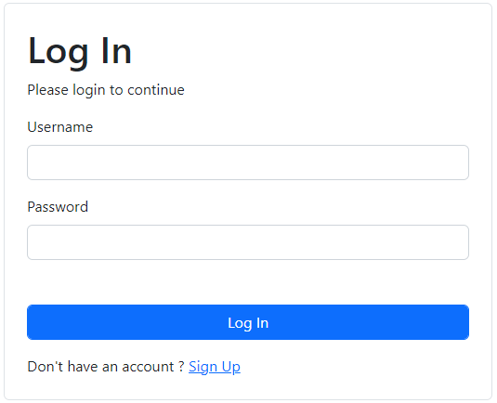

The “Sign Up” button would lead the user to this screen. On this screen, users can input their name, email address, password and their desired role in order to create a designated account for them.

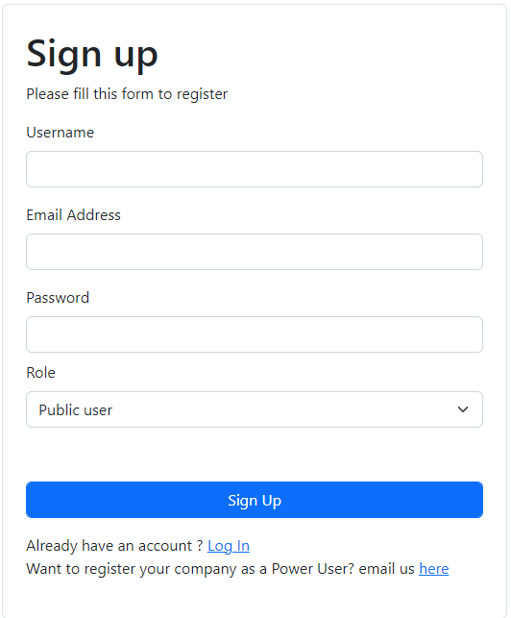

*Public User - General public who want to look at a general view of traffic forecasting used for their daily travels*

*Power User - LTA*

Once done, users would now be able to log into their respective account.

## 2.3 Profile

After Login / Sign Up, the webpage would open the main menu. By clicking on the user’s name on the top left corner, this would lead them to the profile page.

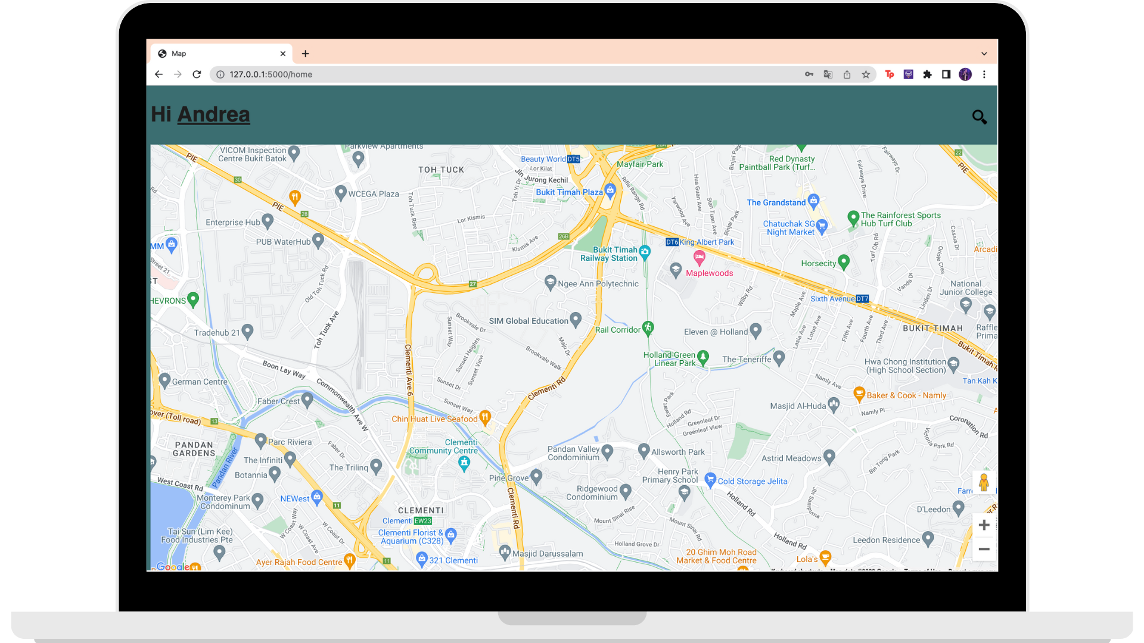

### 2.3.1 Profile Page for Public/Power Users

For Public / Power users, users should be able to see your username displayed on the profile page. From here, users would be able to use this page to change your passwords or to log out.

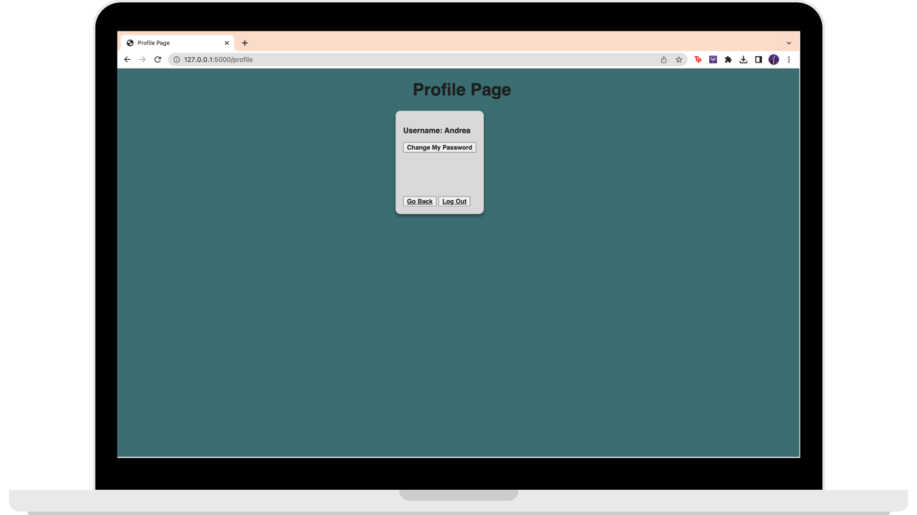

#### 

#### Password Change

In case the user require a password change, users would be able to do so by pressing on the “Change My Password” button found on the profile page.

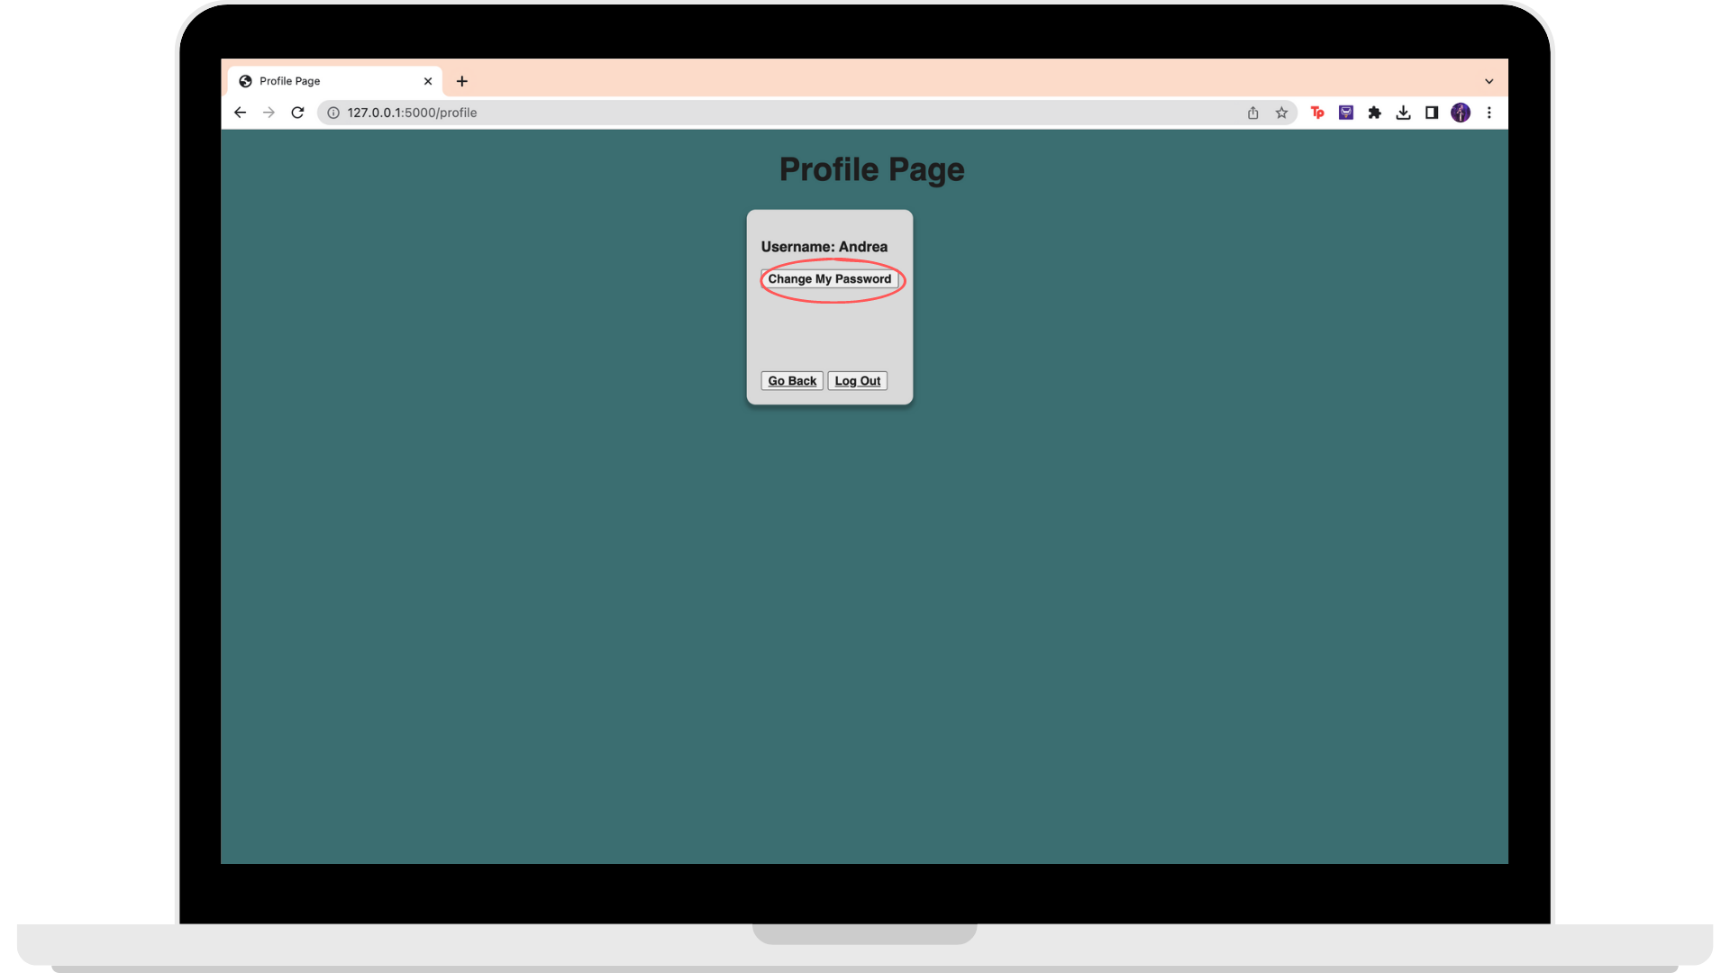

This would lead users to the Password Change page. On here, users would be required to enter their new password twice for confirmation. Once done, users can press the “Change Password”, allowing their password to be set to the new one.

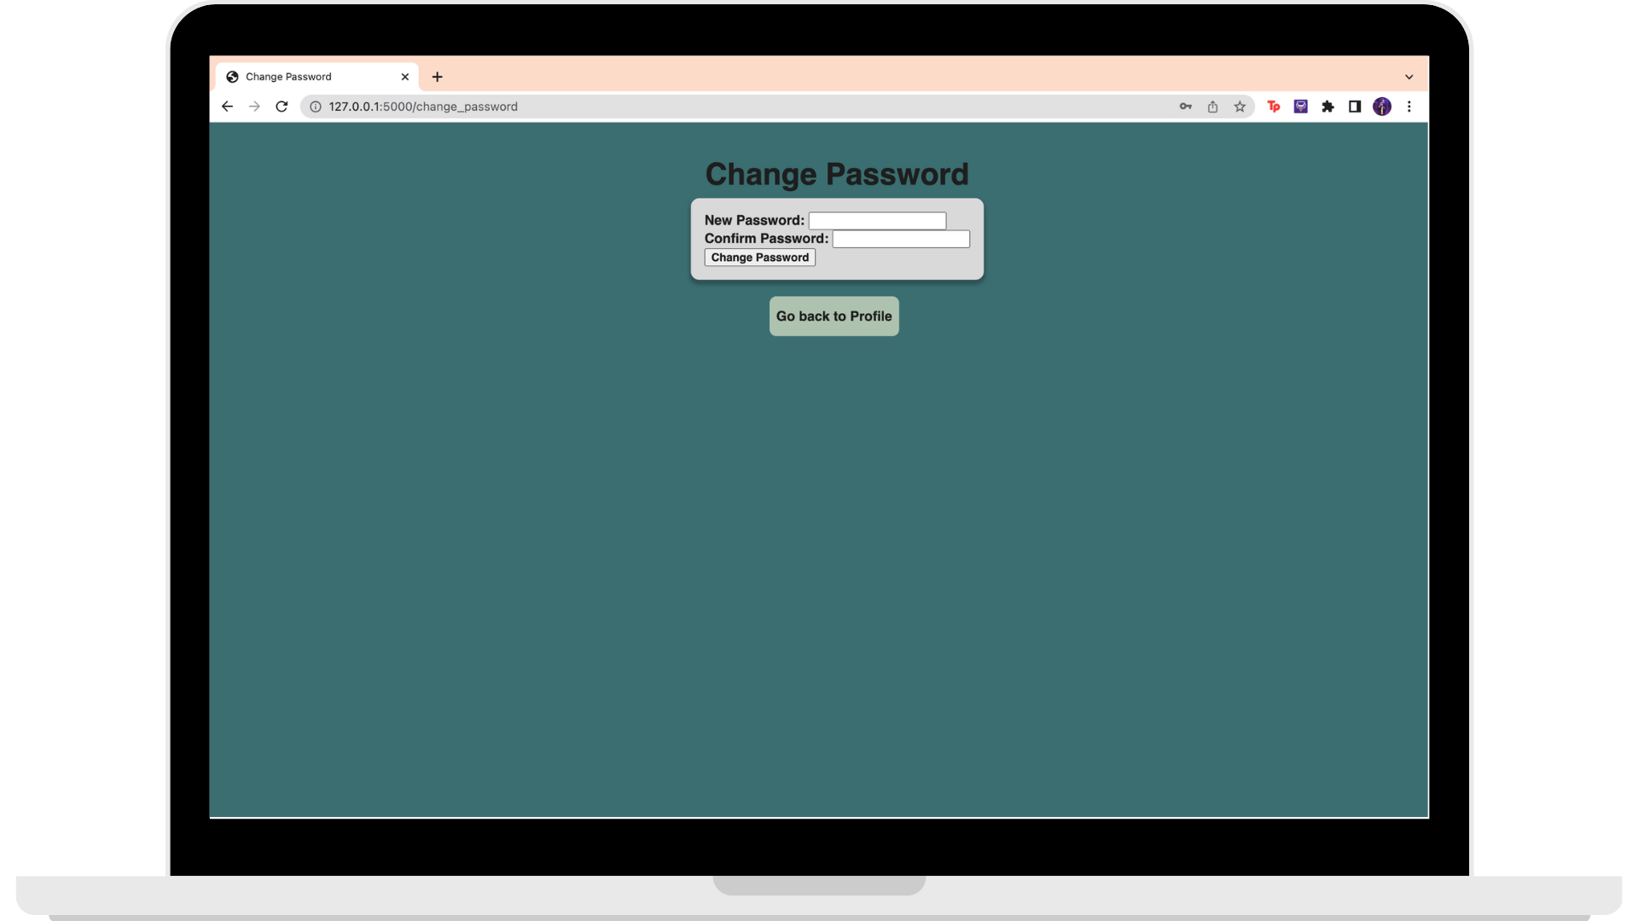

#### 

#### Log Out

When users are done with the website, they can simply log out from their account via the profile page and pressing on the “Log Out” button.

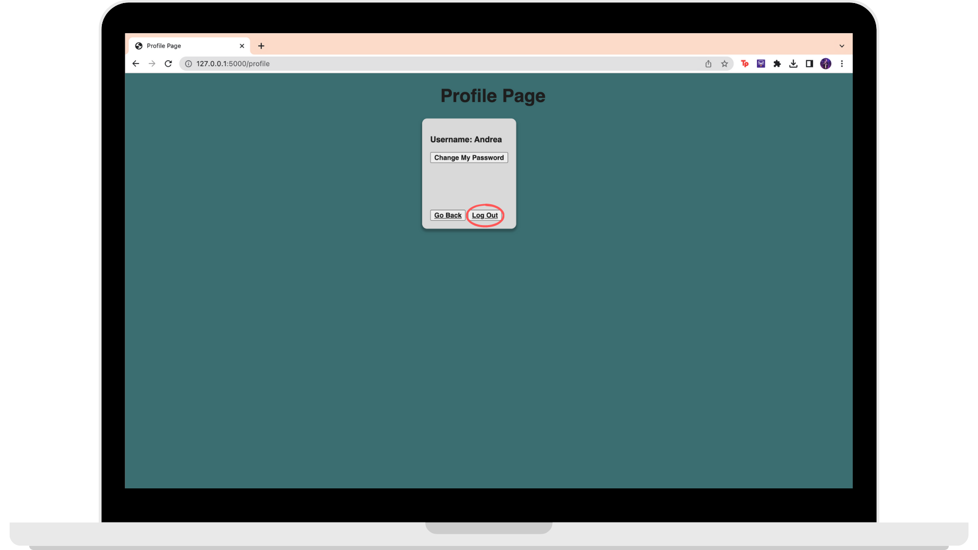

### 2.3.2 Profile Page for Admin Users

For Admin users, users would be able to view all of the user accounts on the page.

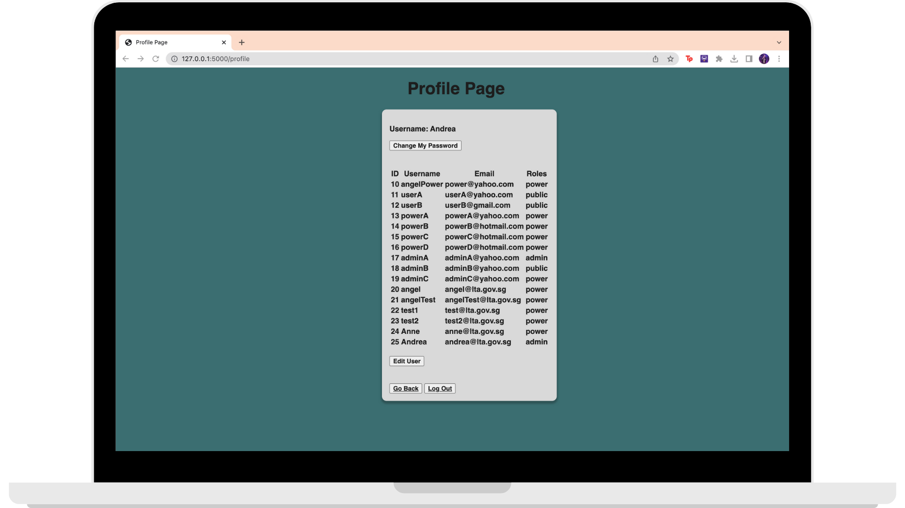

Admin users can press on the “Edit Users” button to make any edits regarding any users’ accounts.

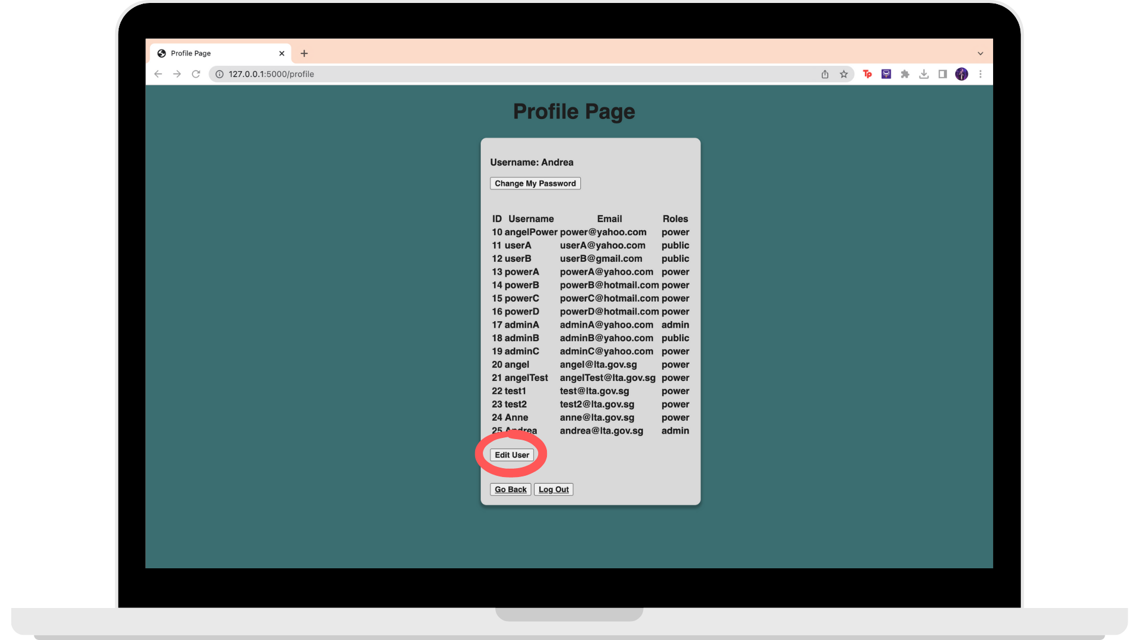

When pressed, a pop up would appear to allow admins to edit any of the users’ details.

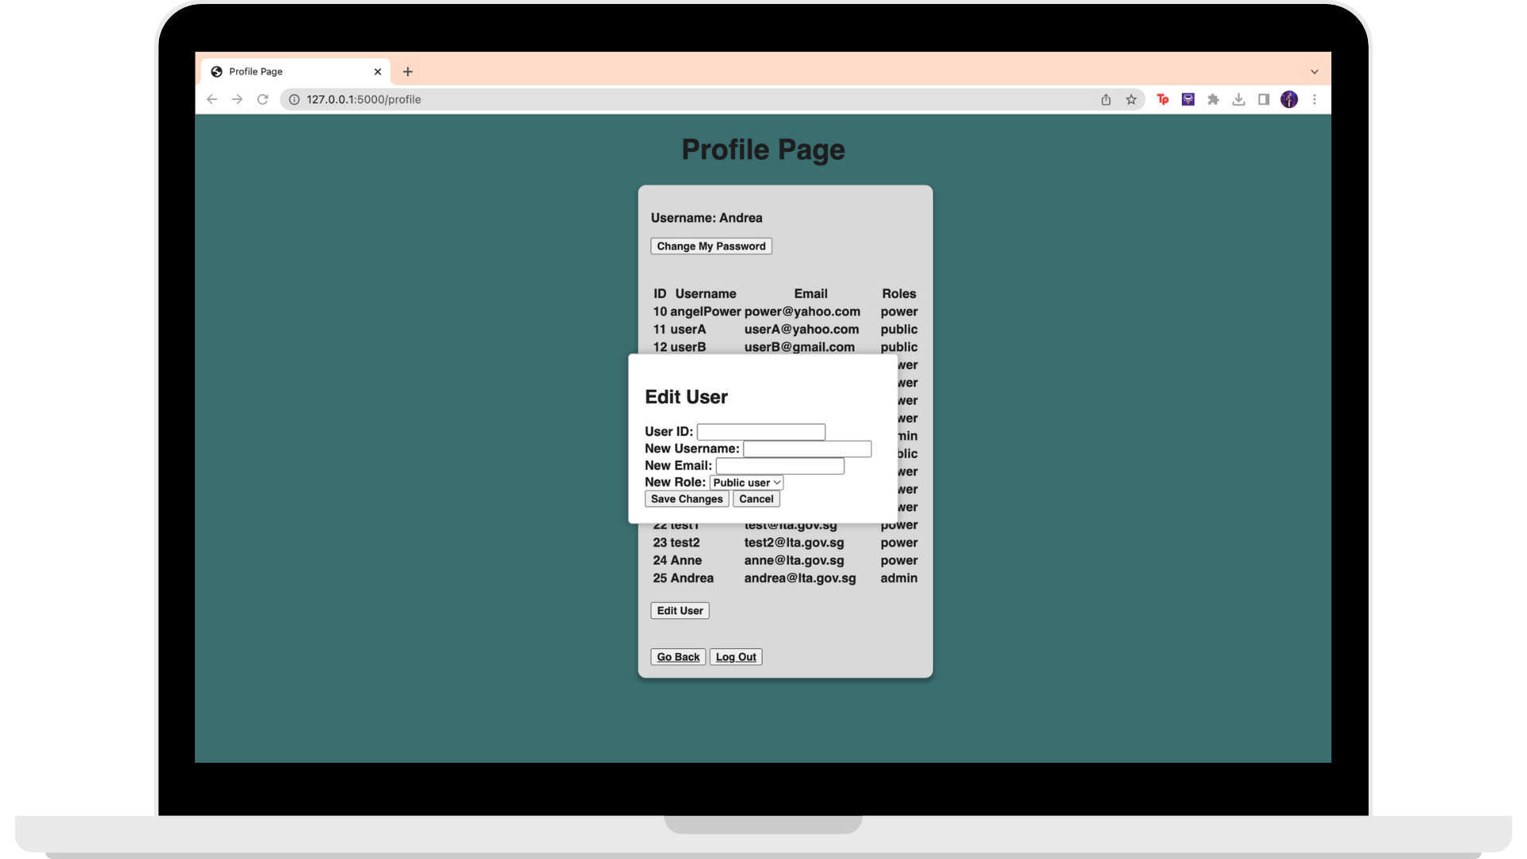

## 2.4 Routing

In order to use our map routing feature, users would first have to input their locations. To do so, they can press on the search button on the top right corner to open the search drop down.

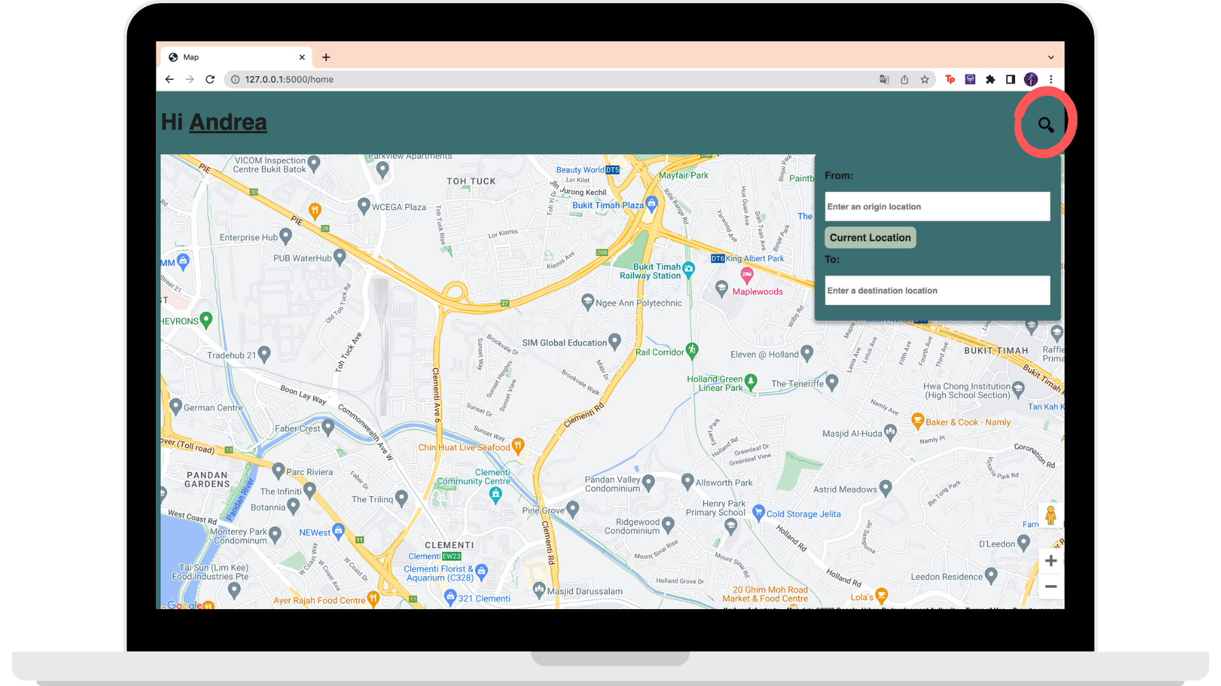

Firstly, users are required to enter their origin destination. They can do this by either by manually choosing their location using the suggestion box or pressing on the “Current Location” button. The “Current Location” button would automatically set their origin location to wherever they are at this moment.

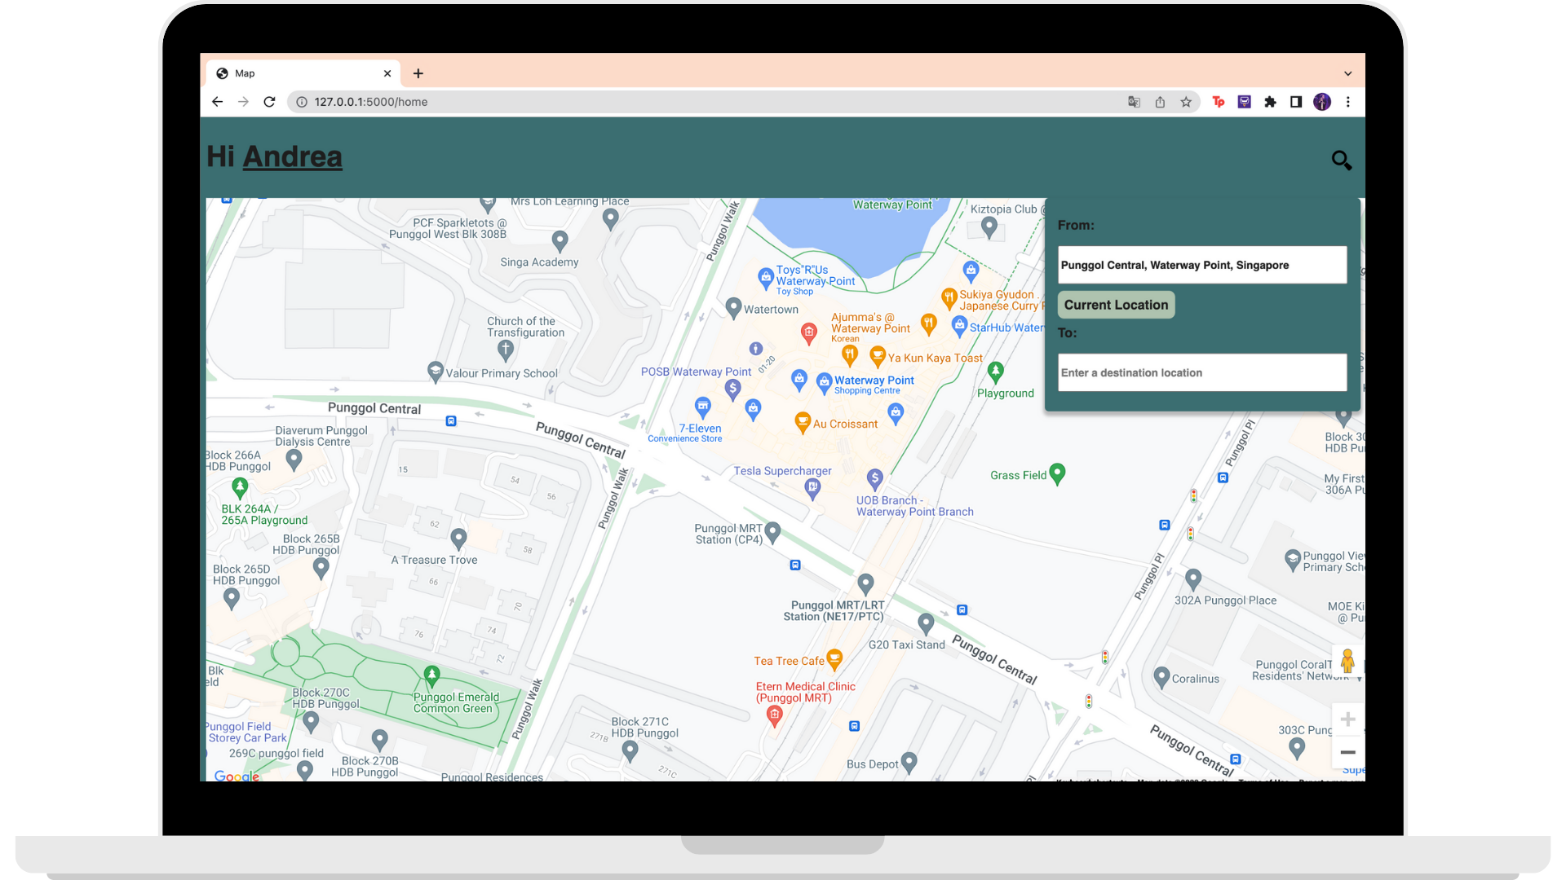

Next, users are now required to enter their destination location under the “To” input box by choosing their location using the suggestion box. Once entered, the page would automatically show the best suggested route to the users’ desired final destination.

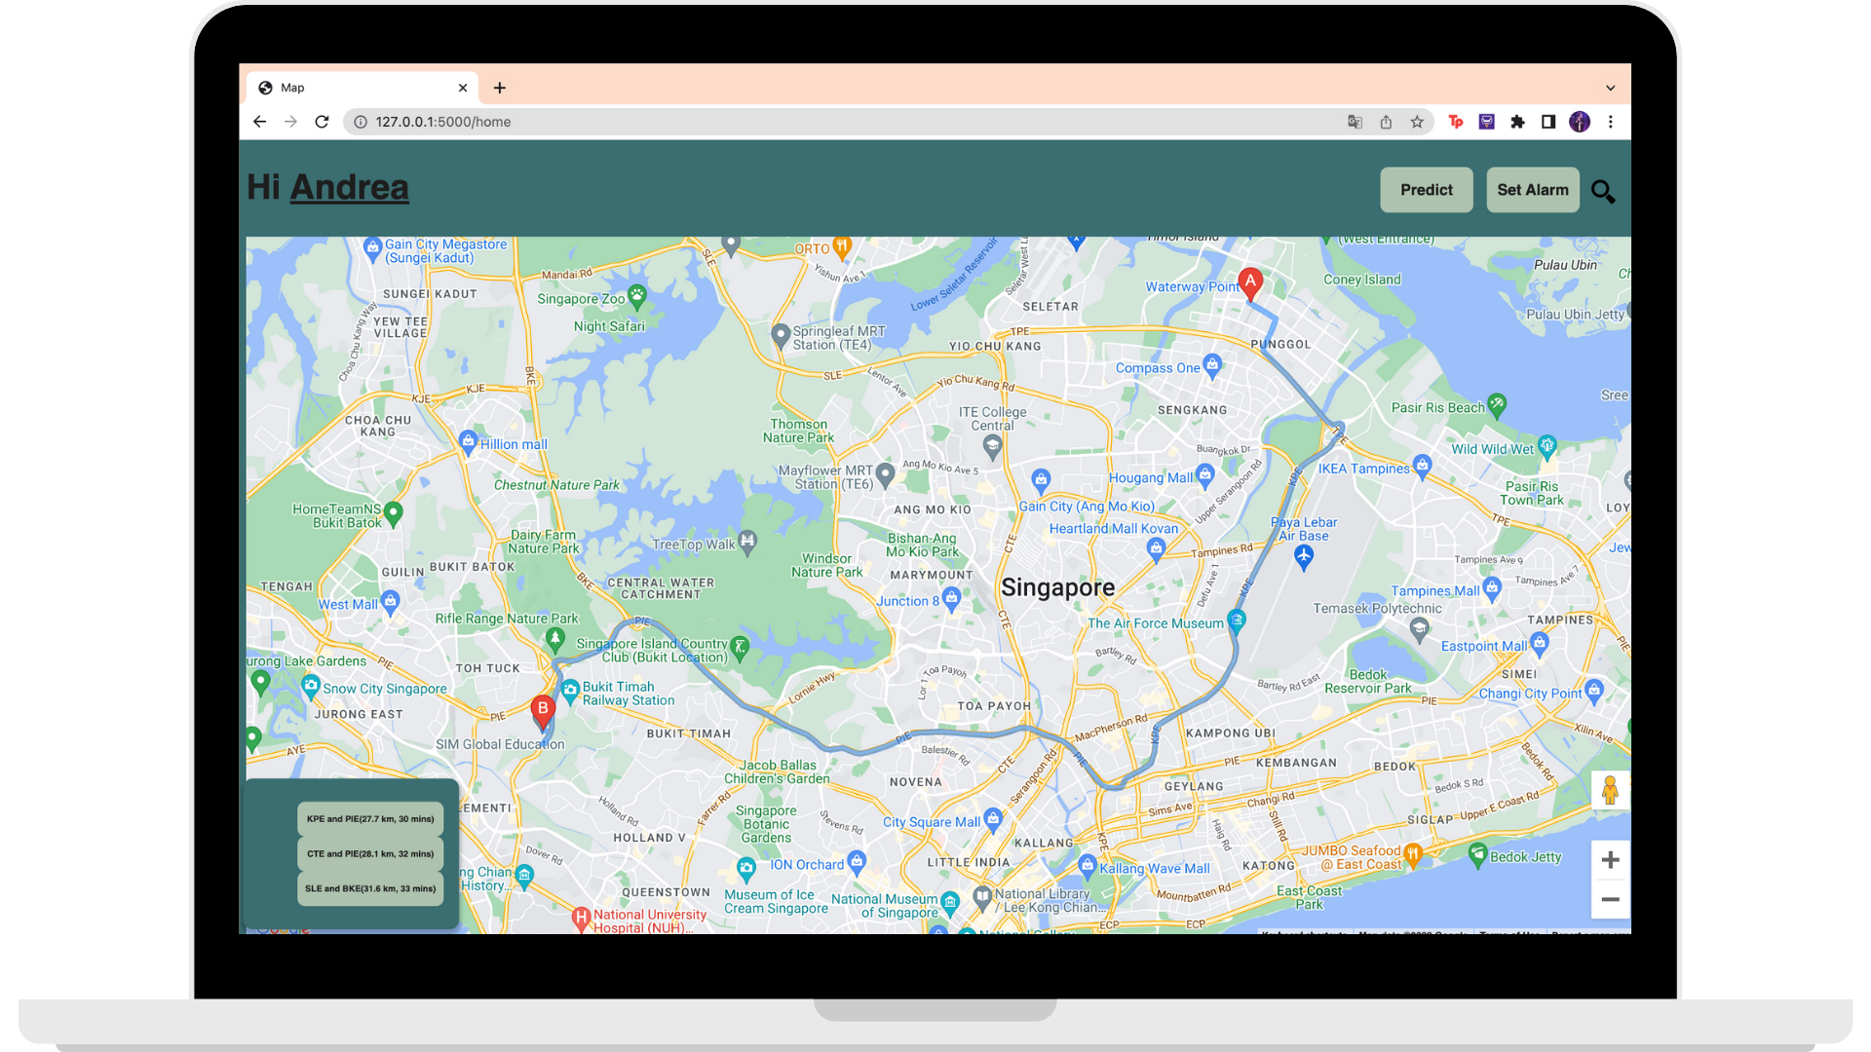

#### Alternative Routes

At the bottom-left of the page, there are other suggested routes given to the users with their respective travel duration.

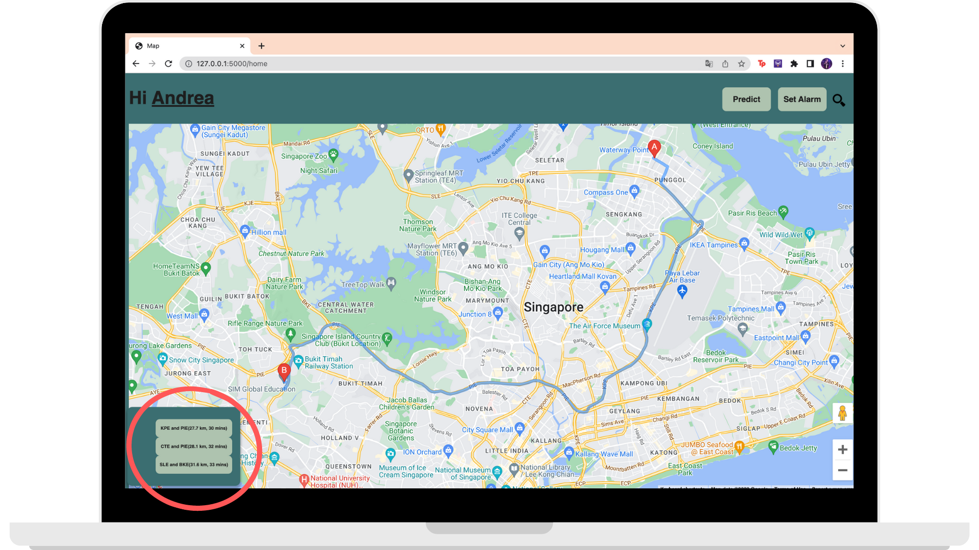

By pressing on any of the alternative routes button, the map routing would change respectively.

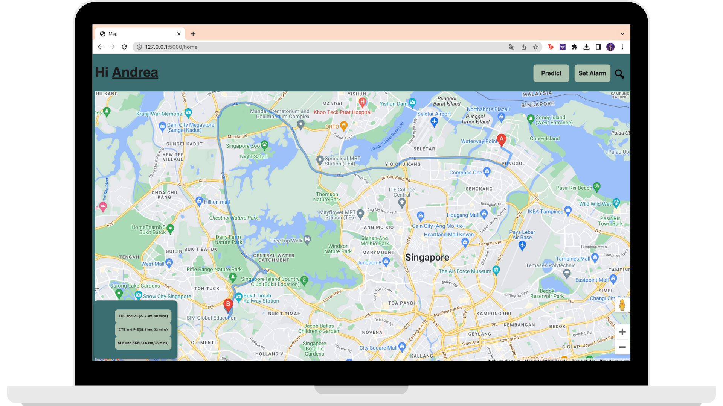

## 

## 2.5 Traffic Prediction

In case of any incidents along the suggested route happening at the moment, users can mark it on the map.

Firstly, users can press on the location of the incident.

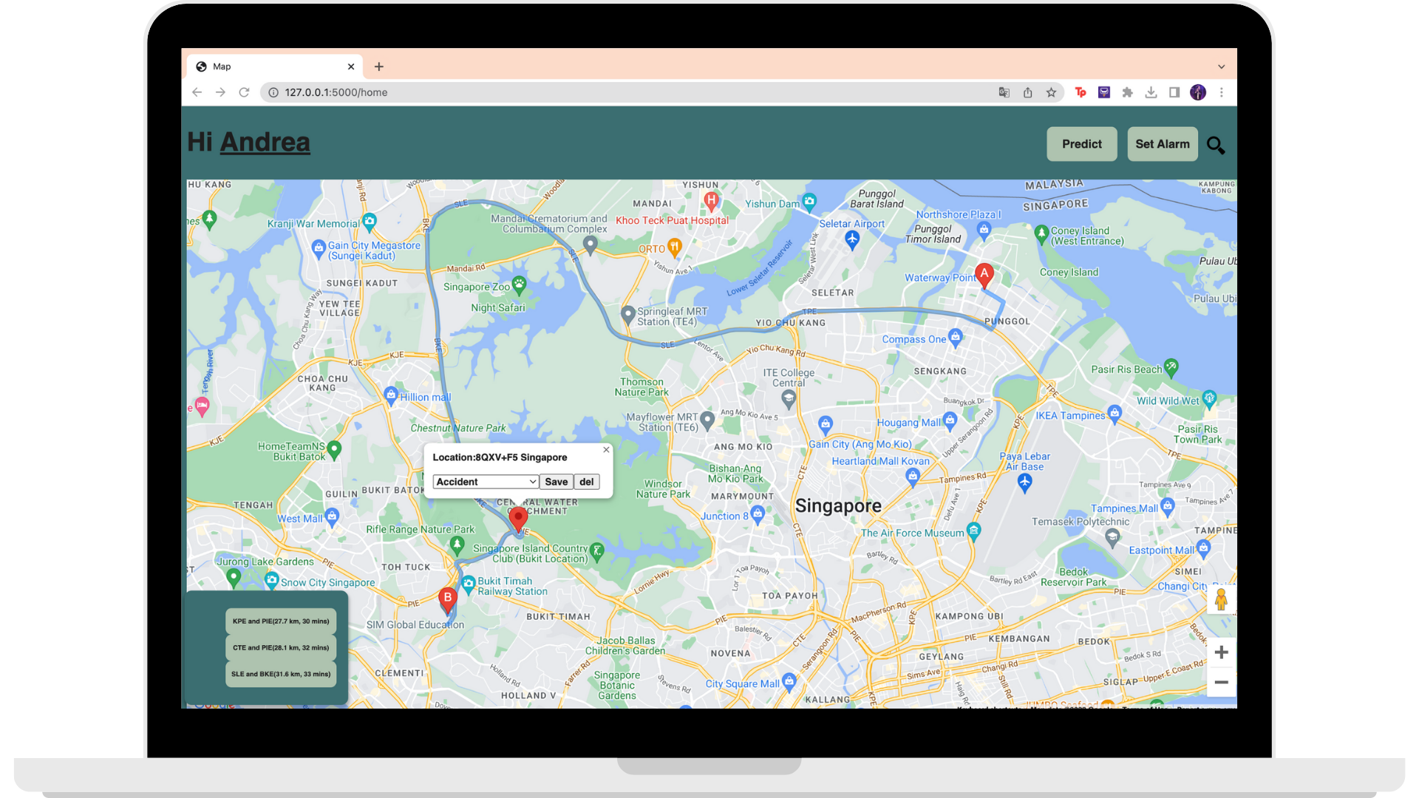

Secondly, users can use the drop down to choose the type of incident. Once done, users would have to press the save button to submit the incident.

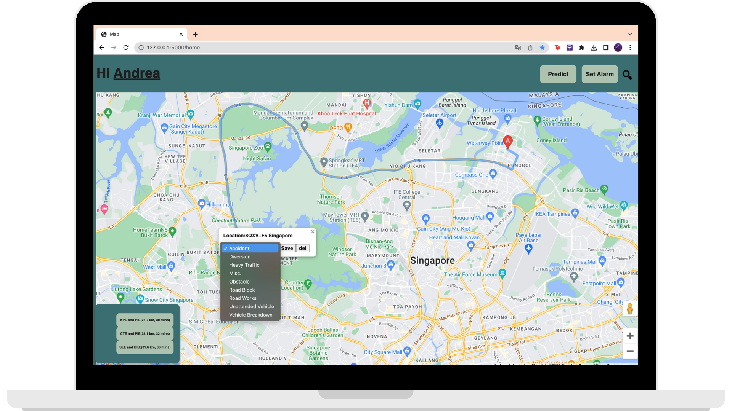

Next, by clicking on the prediction button, a drop down would pop out that includes input fields that allows users to enter any other information that user would require in the prediction.

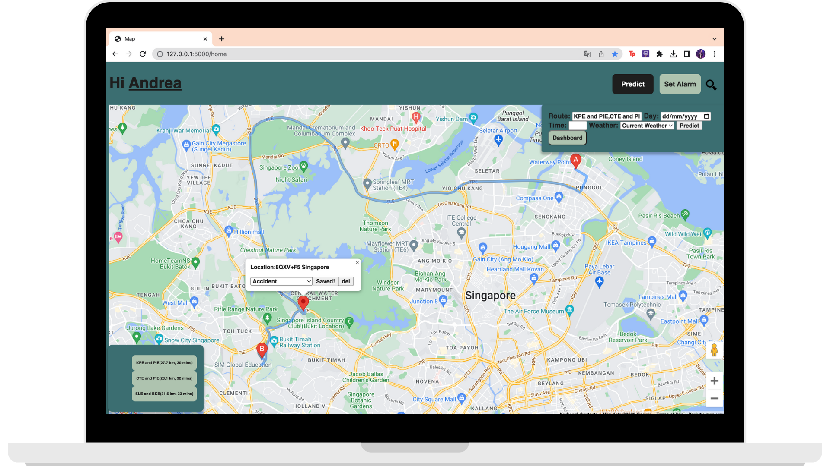

When everything is done, users can press on the predict button.

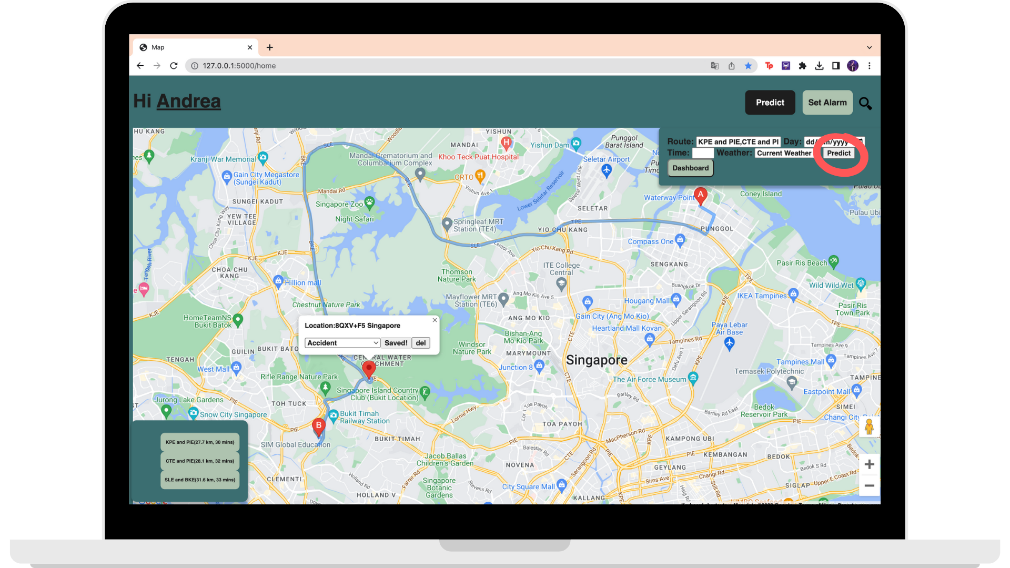

Once the website is done loading, users would be able to view the details of the traffic on each route found at the bottom left (route buttons). The buttons shows the additional time & traffic volume caused by the incident.

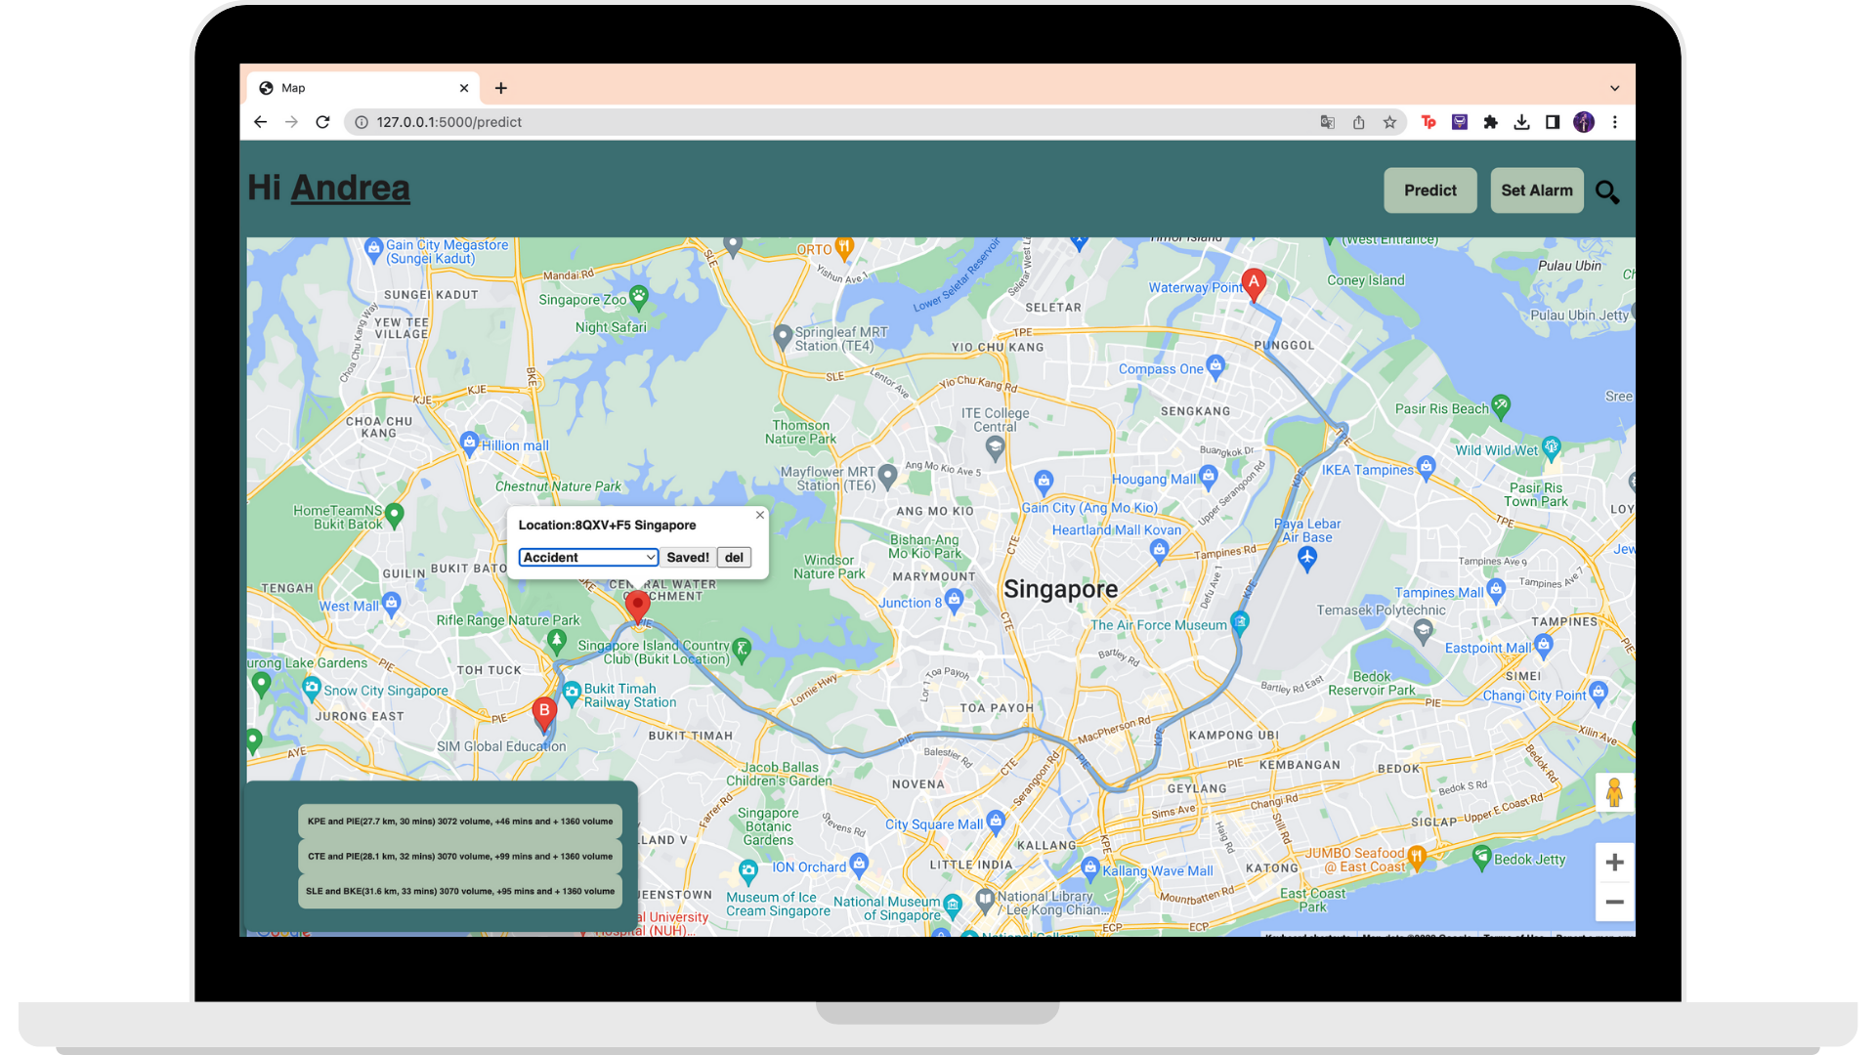

### 2.5.1 Dashboard

Users are able to view a dashboard based on the details of the route. Users can do so by pressing the “Dashboard” button in the “Predict” drop-down.

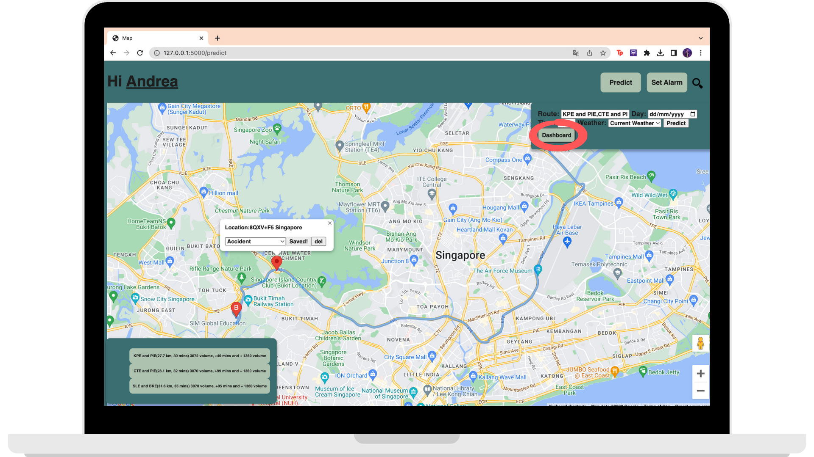

This would open a page filled with traffic information on the left as well as the route on the right.

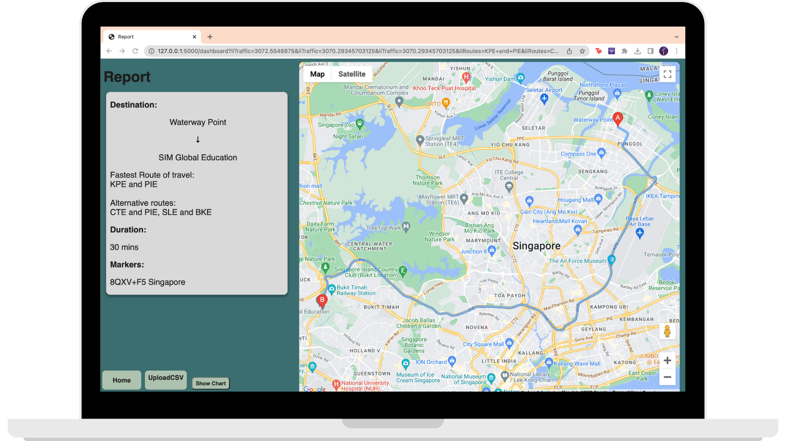

By clicking on the “Show Chart” button on the bottom left corner of the page, users would see the map change into a chart that shows a chart based on the Traffic Volume of Roads.

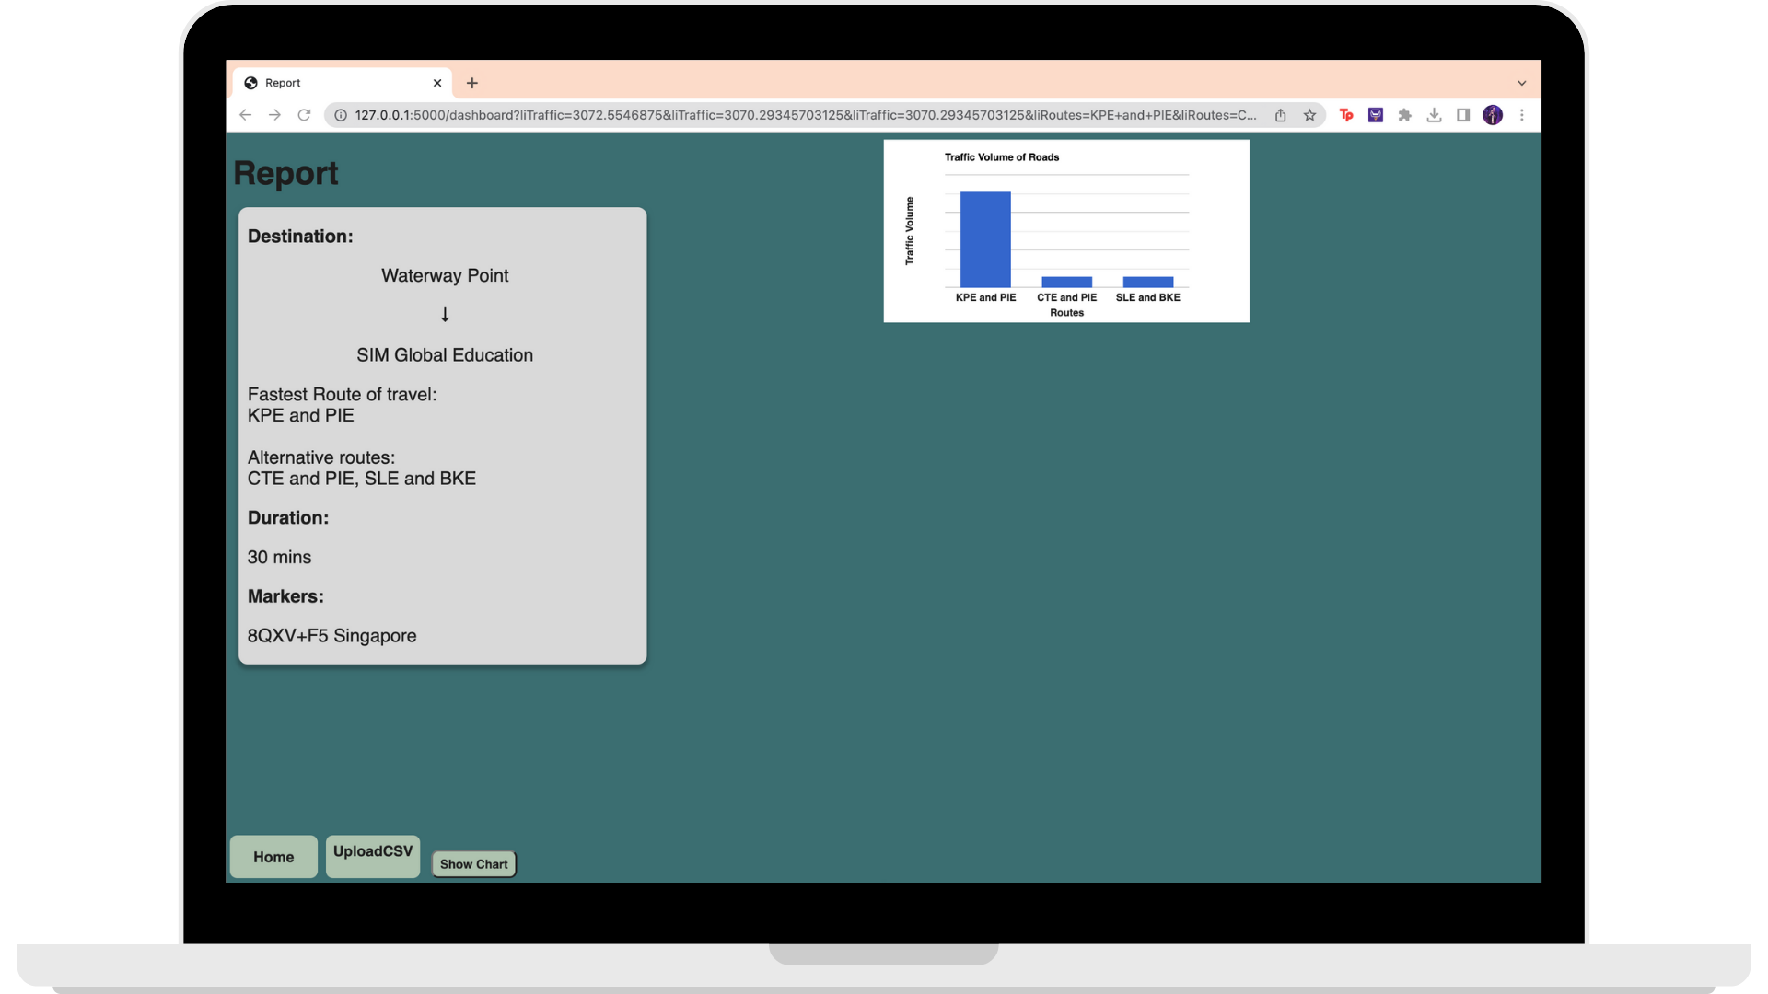

#### 

#### Uploading Your Own Dataset (Power Users Only)

Power users will be able to see a “Upload To Csv” button on the bottom left corner. This allows users to be able to upload their own dataset and view charts based on their own traffic data.

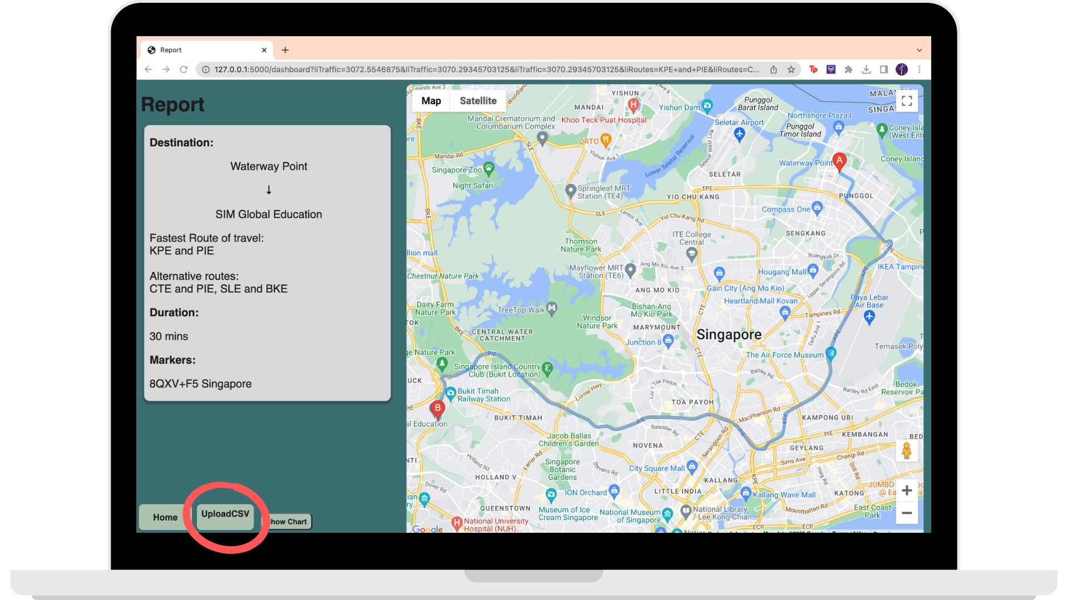

This would lead users to a page filled with the information required in the dataset in order for the feature to work.

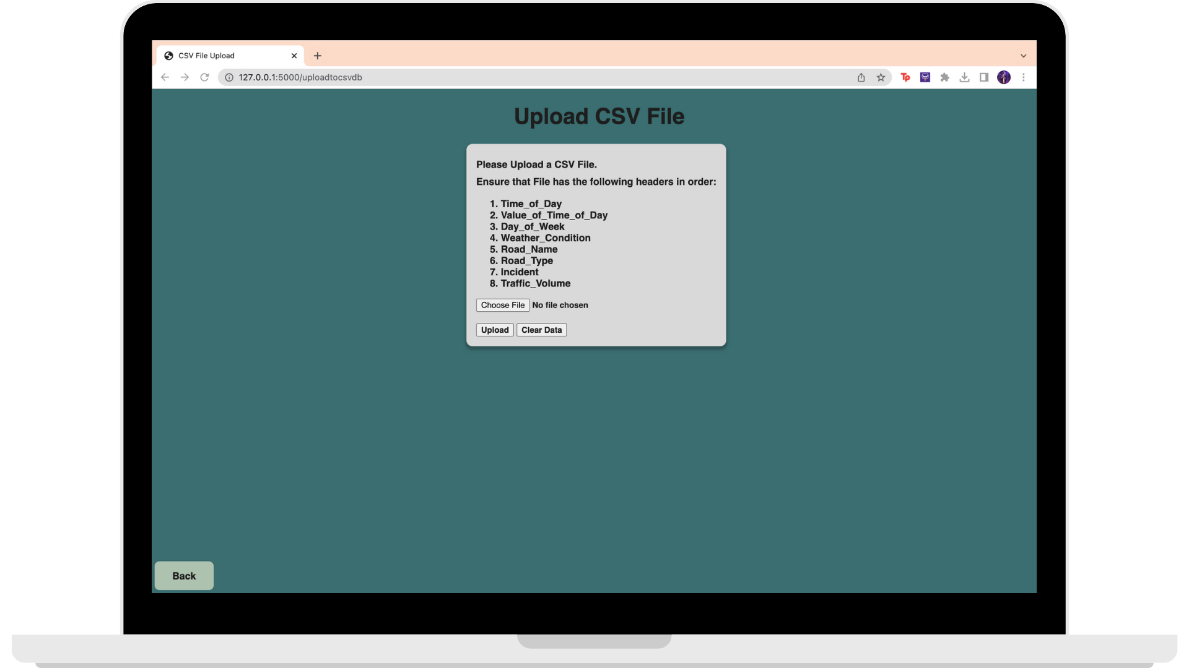

Users would first click on the “Choose File” button to upload their dataset (.csv).

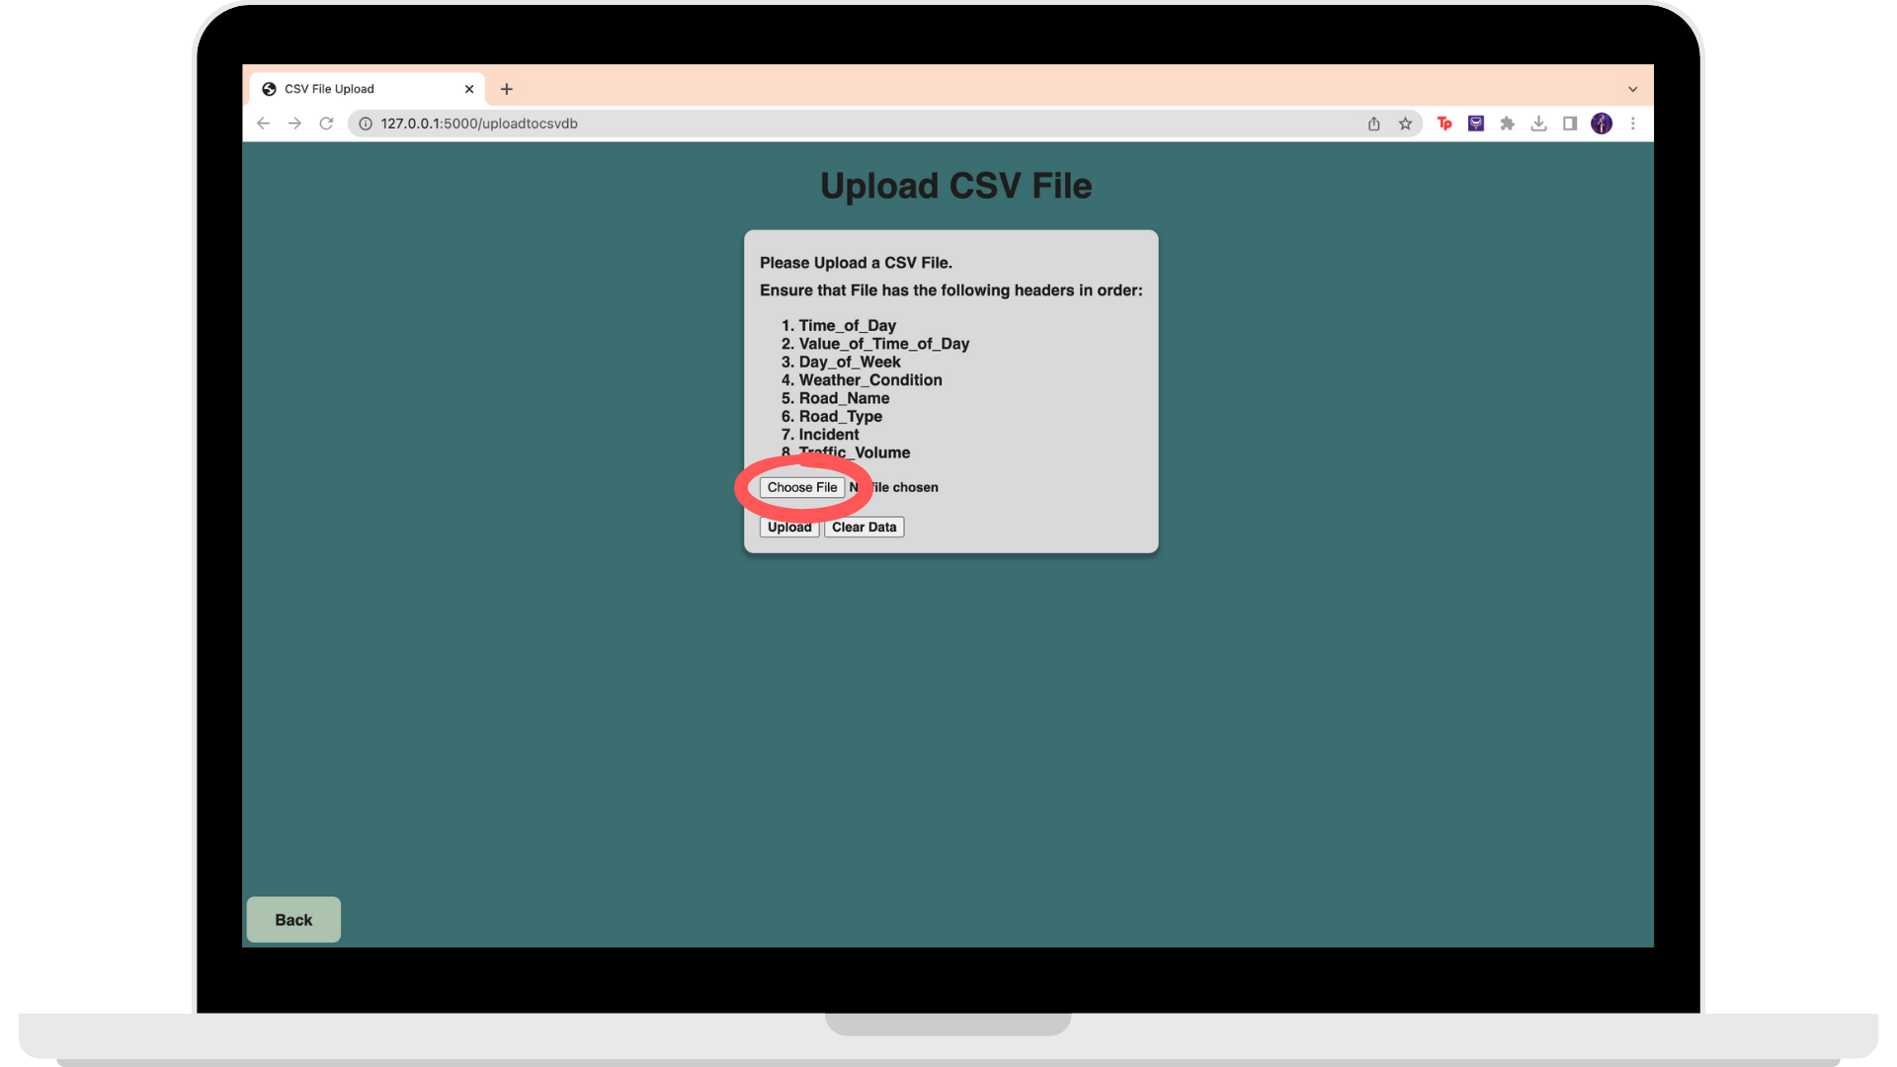

When done, press upload.

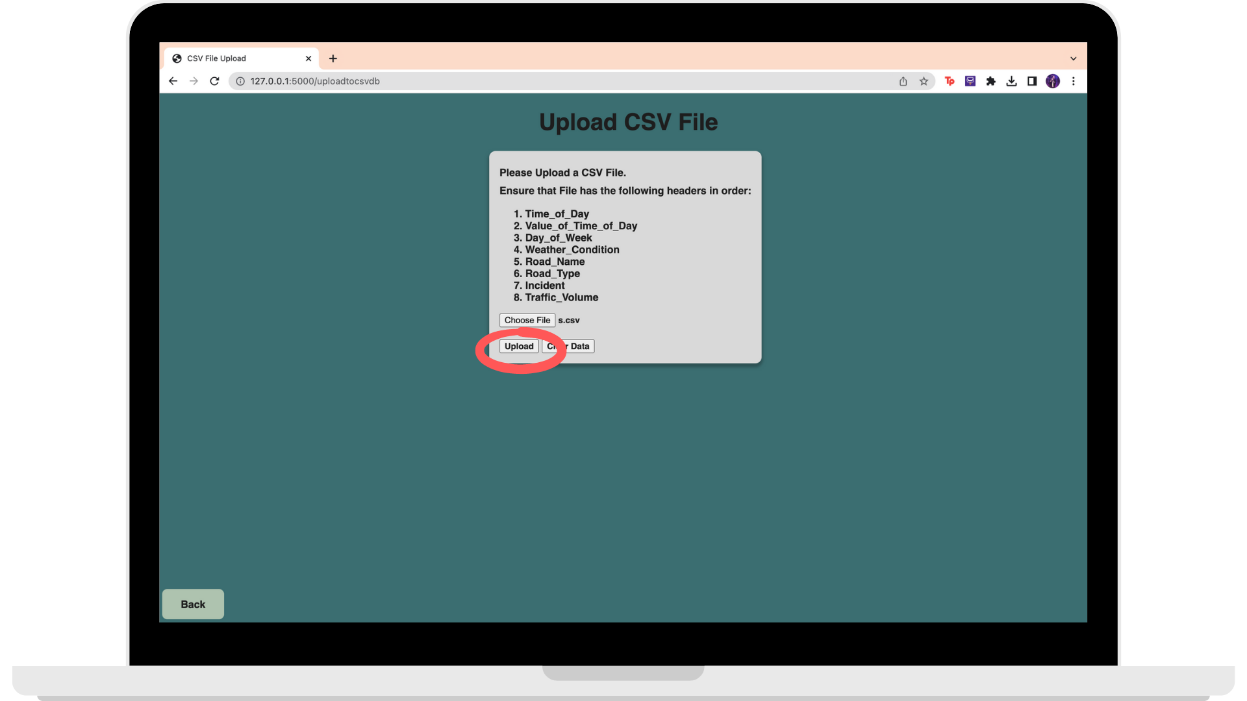

Once the website has loaded the dataset, a list of charts would appear at the bottom. Users can choose whichever chart to view.

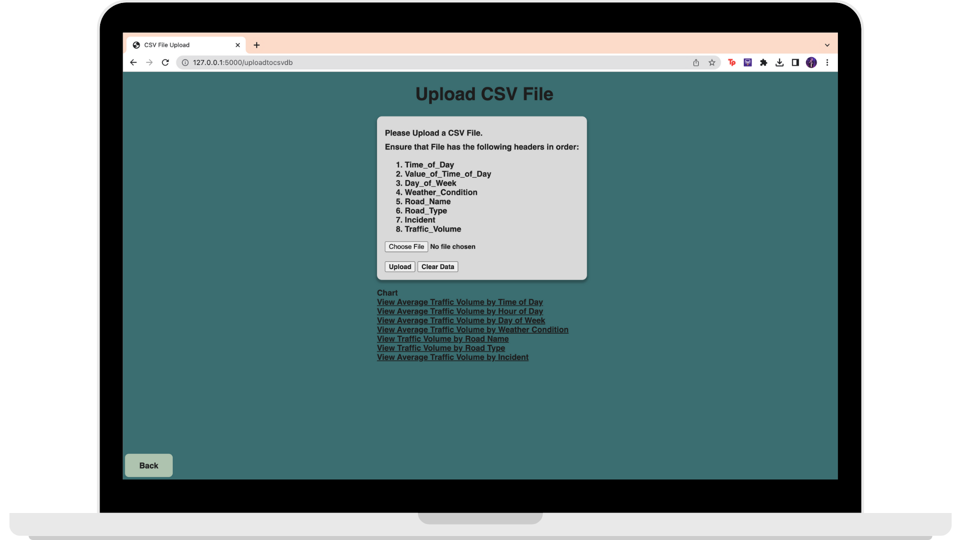

# 3. Local Host

## 3.1 Pre-requisite

### 3.1.1 Admin

As an admin, these steps are required in order to run the website.

Step 1: Install XAMPP (<https://www.apachefriends.org/download.html>)

Step 2: Download the database folder and store it on XAMPP/htdocs directory

Step 3: Start up XAMPP and click “Start” on Apache and SQL

Step 4: Go to any web browser and type “localhost” which will redirect the admin to the main page for XAMPP

Step 5: Click on “phpMyAdmin” that is on the top bar. This would redirect you to the main page of phpMyAdmin

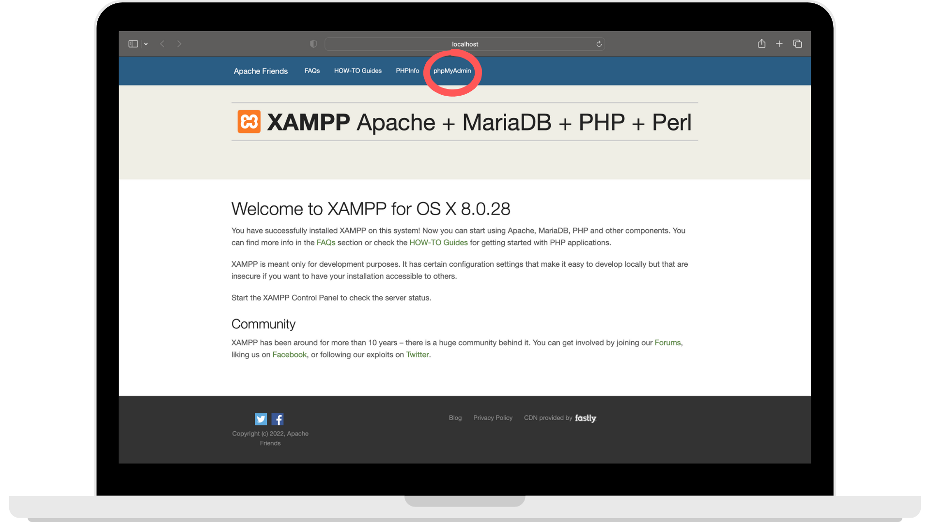

Step 6: Click on “New” on the left, then SQL tab on the top

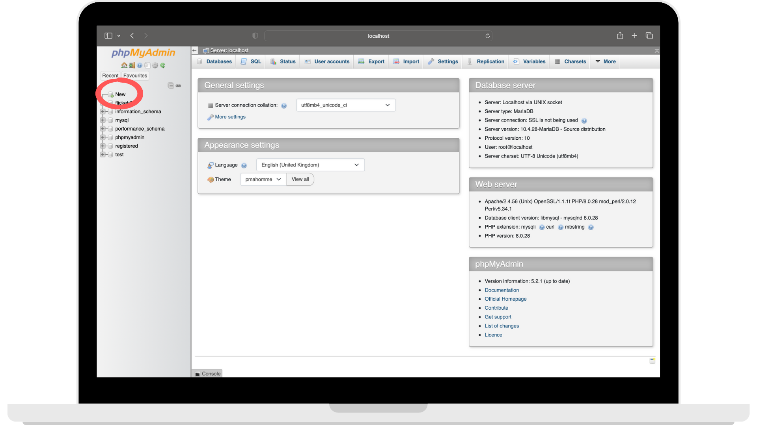

Step 7: Type “registered” as the database name and press the “Create” button

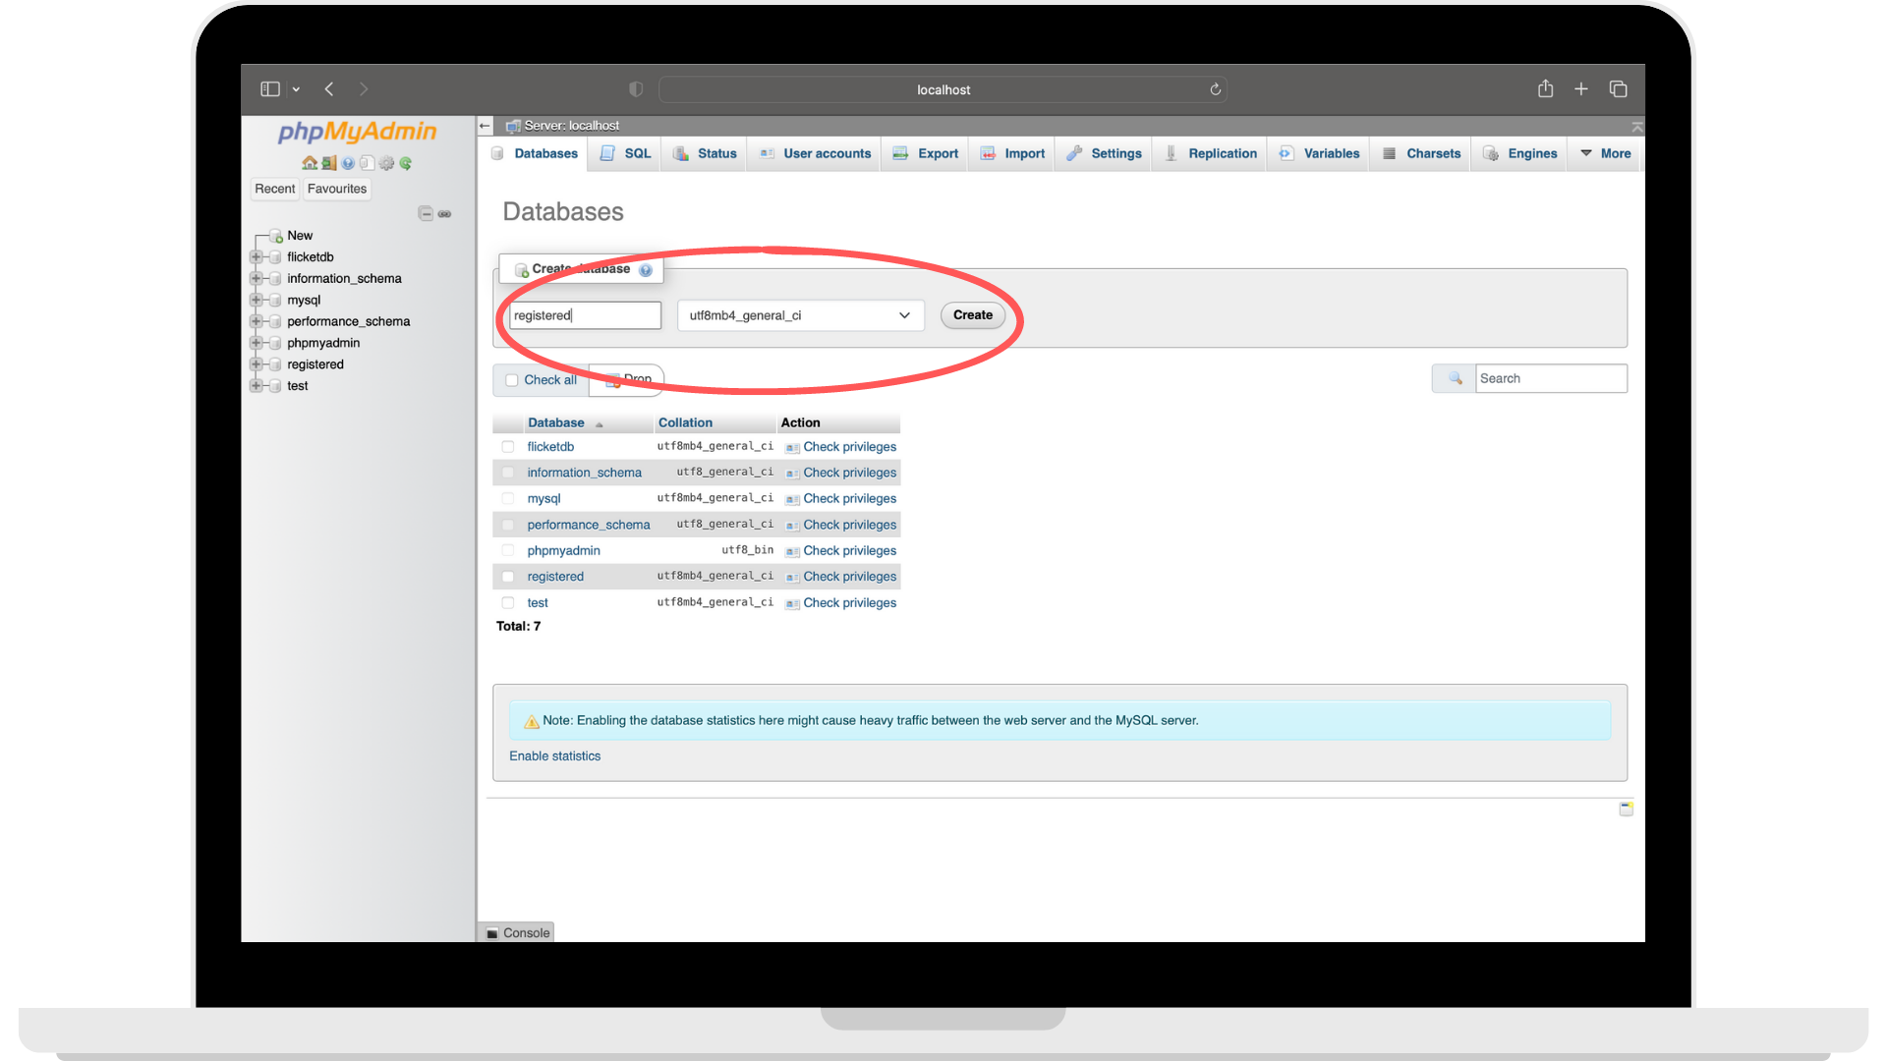

Step 7: Go to import and import registered.sql into the database

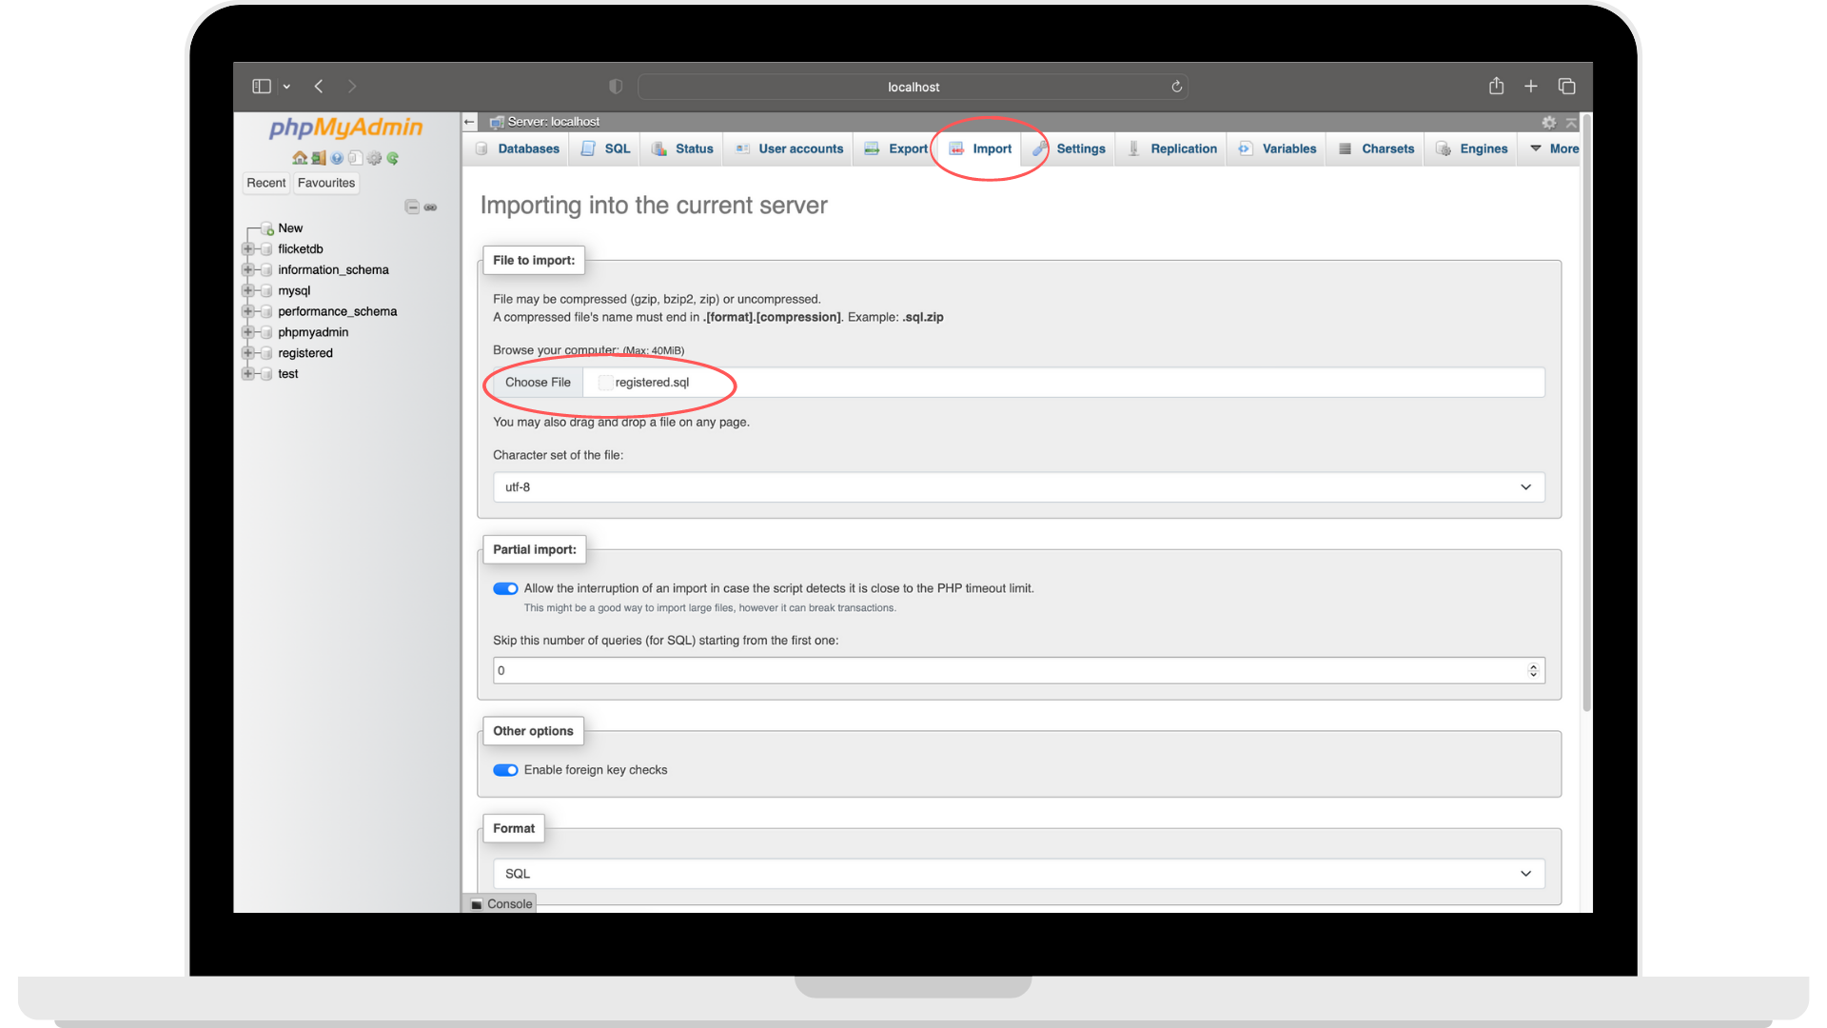

### 3.1.2 Users

* Internet is required to be able to run the website on desktop/mobile
* Users are also required to register for an account in order to use the website.

### 3.1.3 Power Users

As a power user, users would be required to have a certified LTA email in order to be able to register as a power user.

Users can email us by clicking on the link at the registered page if they do not have a certified LTA email yet.

## 

## 3.2 Log In / Register

### 3.2.1 Log In

At the first launch of the webpage, the Login page would show up. Here, users will need to enter their username and password in order to log into their personal accounts.

### 

### 3.2.2 Register

However, if the user does not have an account, they are able to choose to sign up by clicking on the “Sign Up” link at the bottom of the log in button.



The “Sign Up” button would lead the user to this screen. On this screen, users can input their name, email address, password and their desired role in order to create a designated account for them.



*Public User - General public who want to look at a general view of traffic forecasting used for their daily travels*

*Power User - LTA*

Once done, users would now be able to log into their respective account.

## 3.3 Profile

After Login / Sign Up, the webpage would open the main menu. By clicking on the user’s name on the top left corner, this would lead them to the profile page.



### 3.3.1 Profile Page for Public/Power Users

For Public / Power users, users should be able to see your username displayed on the profile page. From here, users would be able to use this page to change your passwords or to log out.



#### 

#### Password Change

In case the user require a password change, users would be able to do so by pressing on the “Change My Password” button found on the profile page.



This would lead users to the Password Change page. On here, users would be required to enter their new password twice for confirmation. Once done, users can press the “Change Password”, allowing their password to be set to the new one.



#### 

#### Log Out

When users are done with the website, they can simply log out from their account via the profile page and pressing on the “Log Out” button.



### 3.3.2 Profile Page for Admin Users

For Admin users, users would be able to view all of the user accounts on the page.



Admin users can press on the “Edit Users” button to make any edits regarding any users’ accounts.



When pressed, a pop up would appear to allow admins to edit any of the users’ details.



## 3.4 Routing

In order to use our map routing feature, users would first have to input their locations. To do so, they can press on the search button on the top right corner to open the search drop down.



Firstly, users are required to enter their origin destination. They can do this by either by manually choosing their location using the suggestion box or pressing on the “Current Location” button. The “Current Location” button would automatically set their origin location to wherever they are at this moment.



Next, users are now required to enter their destination location under the “To” input box by choosing their location using the suggestion box. Once entered, the page would automatically show the best suggested route to the users’ desired final destination.



#### Alternative Routes

At the bottom-left of the page, there are other suggested routes given to the users with their respective travel duration.



By pressing on any of the alternative routes button, the map routing would change respectively.



## 

## 3.5 Traffic Prediction

In case of any incidents along the suggested route happening at the moment, users can mark it on the map.

Firstly, users can press on the location of the incident.



Secondly, users can use the drop down to choose the type of incident. Once done, users would have to press the save button to submit the incident.



Next, by clicking on the prediction button, a drop down would pop out that includes input fields that allows users to enter any other information that user would require in the prediction.



When everything is done, users can press on the predict button.



Once the website is done loading, users would be able to view the details of the traffic on each route found at the bottom left (route buttons). The buttons shows the additional time & traffic volume caused by the incident.



### 3.5.1 Dashboard

Users are able to view a dashboard based on the details of the route. Users can do so by pressing the “Dashboard” button in the “Predict” drop-down.



This would open a page filled with traffic information on the left as well as the route on the right.



By clicking on the “Show Chart” button on the bottom left corner of the page, users would see the map change into a chart that shows a chart based on the Traffic Volume of Roads.



#### 

#### Uploading Your Own Dataset (Power Users Only)

Power users will be able to see a “Upload To Csv” button on the bottom left corner. This allows users to be able to upload their own dataset and view charts based on their own traffic data.



This would lead users to a page filled with the information required in the dataset in order for the feature to work.



Users would first click on the “Choose File” button to upload their dataset (.csv).



When done, press upload.



Once the website has loaded the dataset, a list of charts would appear at the bottom. Users can choose whichever chart to view.



## 3.6 Set Alarm

In order to set an alarm, users can press on the “Set Alarm” button found on the main page.

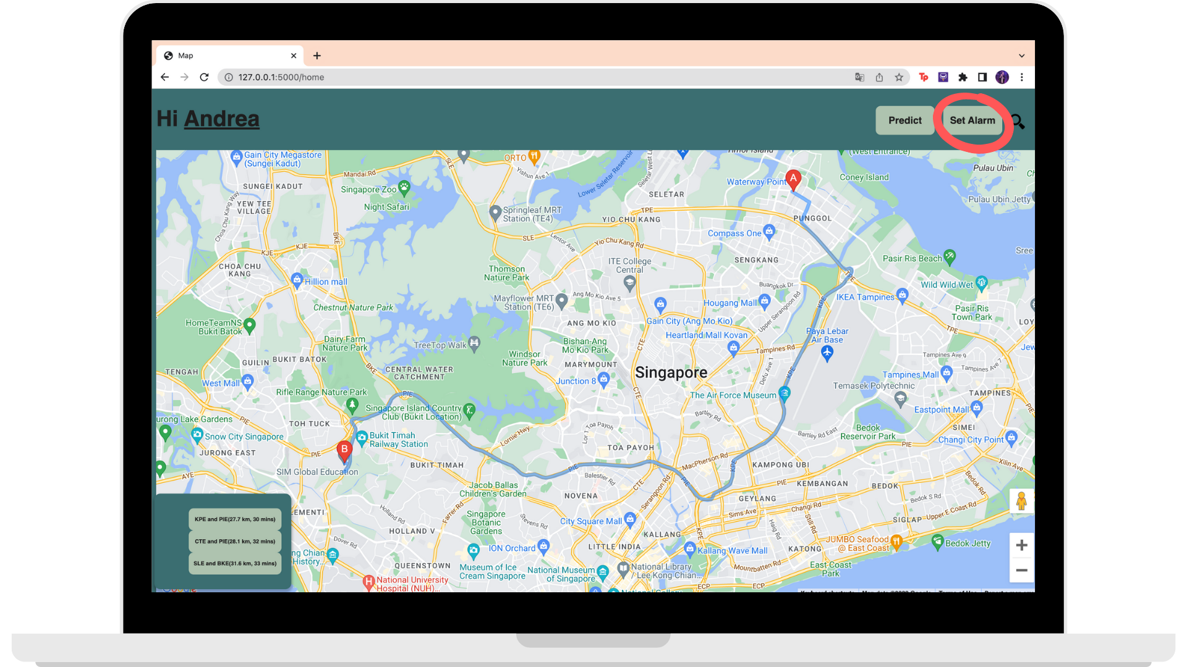

This would lead users to this page. Here, users can key in the necessary information of the route they would need as well as the information of when the alarm would be sent to their email. Once done, press “Set Alarm”.

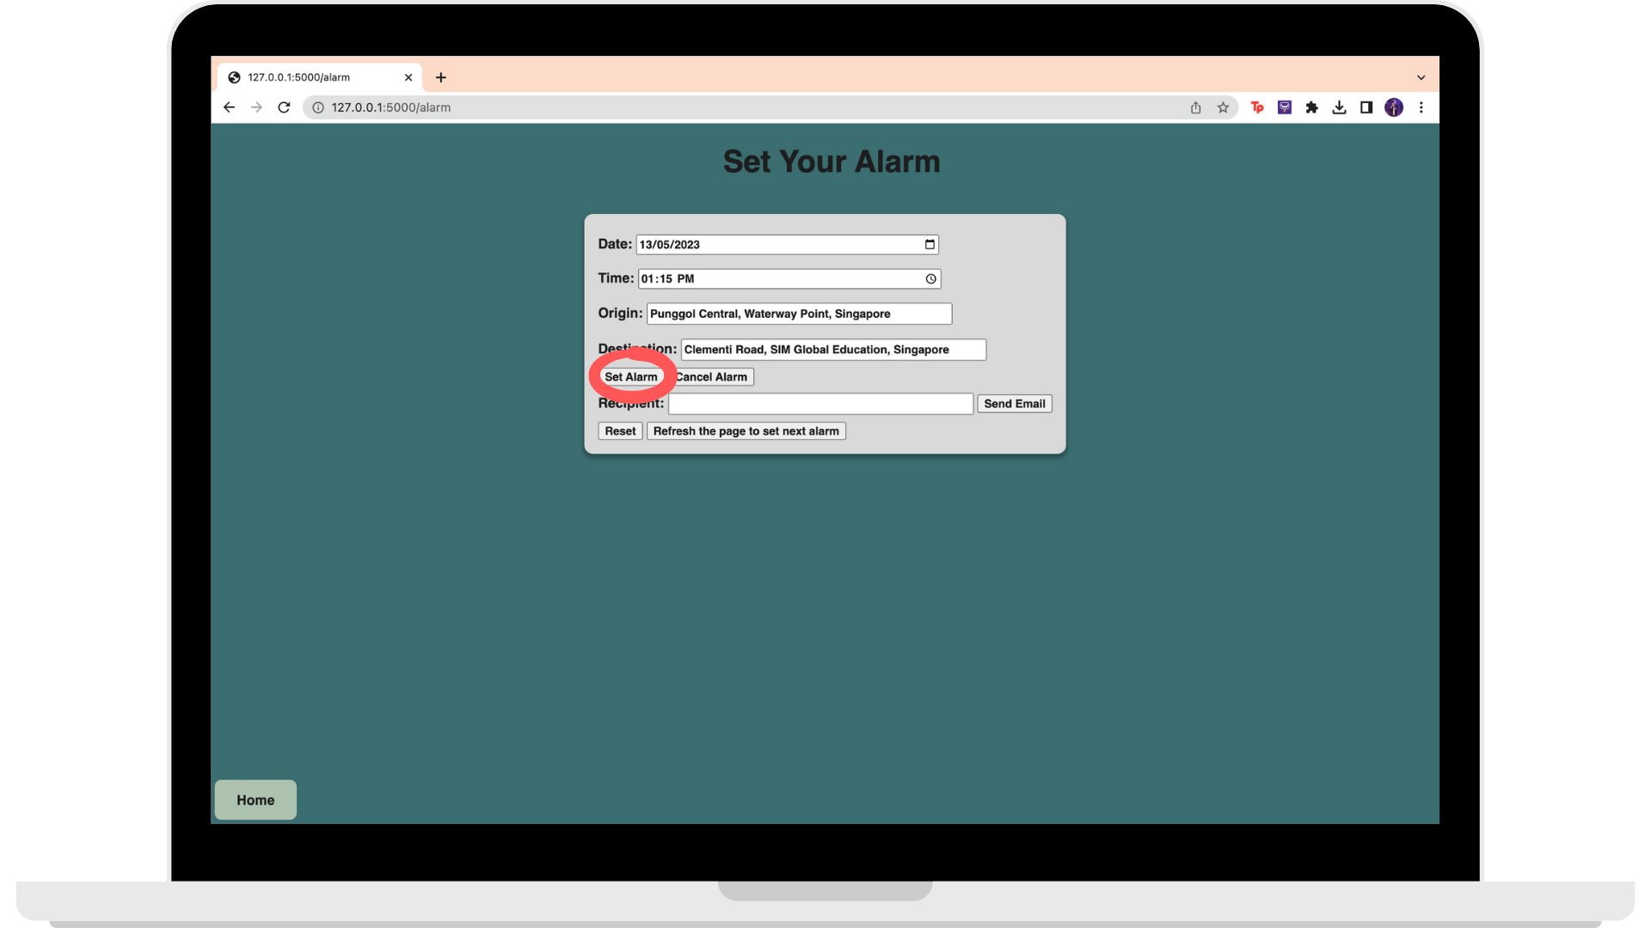

Lastly, users would need to key in their email and then press “Send Email” to activate the email.

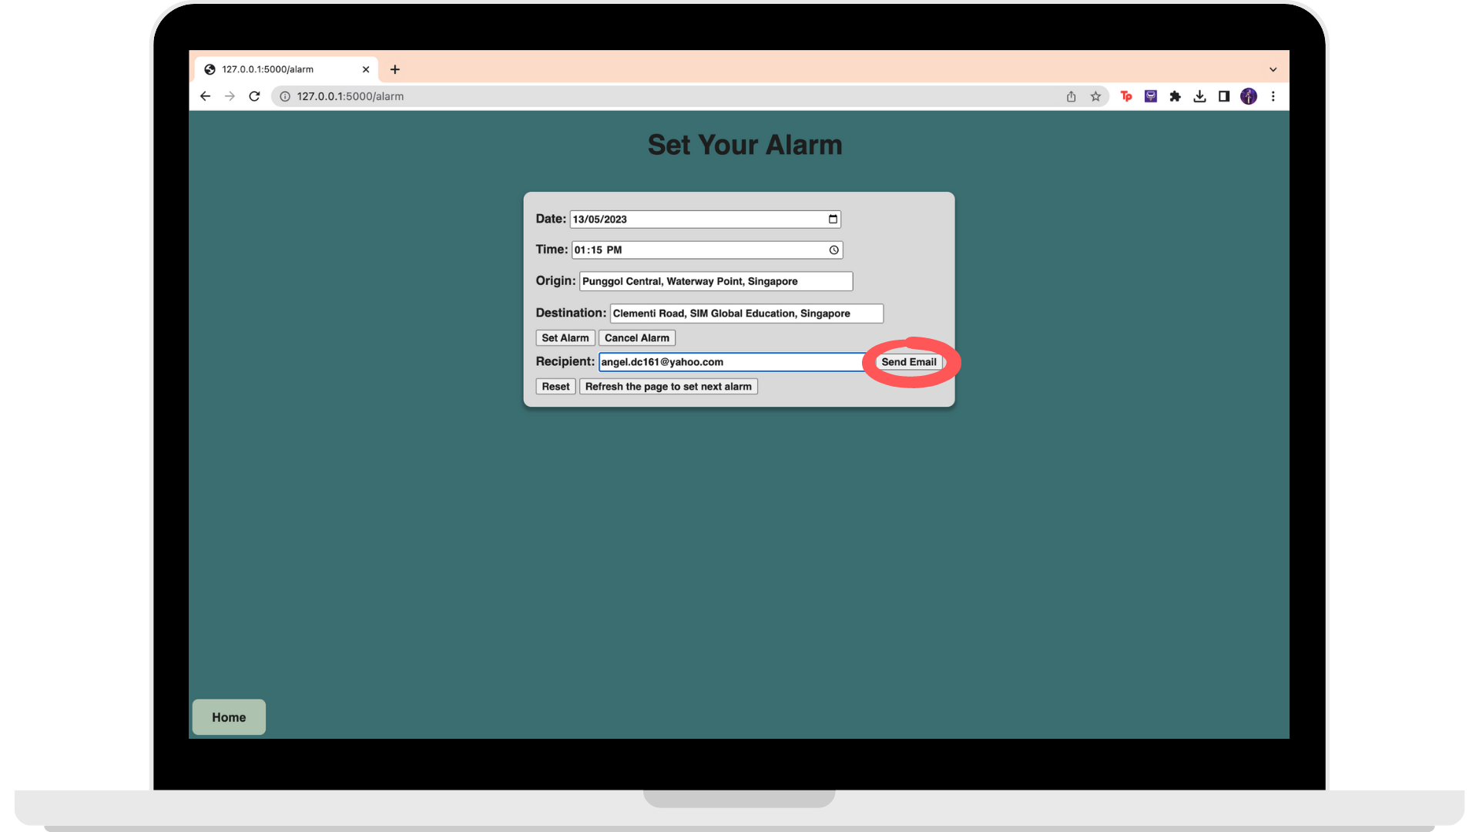

This email would be sent to the user when the time comes.

